* Ctrl+J

how to blend AI and Ml for Unified database Capacity planning

Thought for 36s

### **Blending AI and Machine Learning for Unified Database Capacity Planning**

Database capacity planning involves forecasting resource needs (e.g., CPU, memory, storage, I/O) to ensure optimal performance, avoid downtime, and control costs. Traditionally, this relied on static thresholds or linear trends, but blending AI (for broader intelligence, automation, and decision-making) with ML (for data-driven predictions) enables a unified approach—a centralized, predictive system that handles diverse database types (e.g., SQL, NoSQL, cloud, on-premises) under one framework.

This integration uses ML for accurate forecasting and anomaly detection, while AI orchestrates actions like auto-scaling or recommendations. It creates a "unified" view by aggregating metrics across heterogeneous databases, common in modern data platforms (e.g., Azure Cosmos DB or multi-cloud setups).

#### **Key Benefits**

* Proactive scaling — Predict bottlenecks before they occur.
* Cost optimization — Avoid over-provisioning (e.g., in data centers or cloud).
* Improved accuracy — ML handles seasonality and trends better than manual methods.
* Unified insights — Centralized monitoring for multiple databases reduces silos.



[softwebsolutions.com](https://www.softwebsolutions.com/resources/machine-learning-pipeline/)

Machine Learning Pipeline: Benefits, Use Cases & Best Practices

*The image above shows a typical machine learning pipeline, which forms the core of blending AI/ML for capacity planning.*

#### **Step-by-Step Approach to Integration**

Data Collection and Monitoring (Foundation for Unity)

1. Gather historical and real-time metrics from databases: CPU/memory usage, query latency, storage growth, connection counts, I/O throughput. Use observability tools (e.g., Prometheus, Grafana) or cloud-native services (e.g., Oracle Operations Insights, AWS CloudWatch) for a unified data ingestion layer across multiple databases. This creates a single source of truth, essential for "unified" planning.



[tableau.com](https://www.tableau.com/analytics/what-is-time-series-analysis)

Time Series Analysis: Definition, Types & Techniques | Tableau

*Time series data visualization (like the example above) is key for tracking resource usage trends.*

Data Preparation and Feature Engineering

1. Clean and aggregate data. Engineer features like seasonal patterns (e.g., peak hours), growth rates, or external factors (e.g., application traffic). ML excels here by identifying hidden patterns in time series data.

ML Models for Forecasting and Anomaly Detection

1. Apply time series ML techniques:
   * Classical models: ARIMA or Prophet for trend/seasonality forecasting.

Advanced: LSTM (deep learning) for complex patterns, or hybrid approaches.

Detect anomalies (e.g., sudden spikes) using algorithms like isolation forests or autoencoders.

* + Examples: PostgreSQL deployments use ML to predict seasonal demands; Red Hat's MLASP tool benchmarks system capacity mathematically.

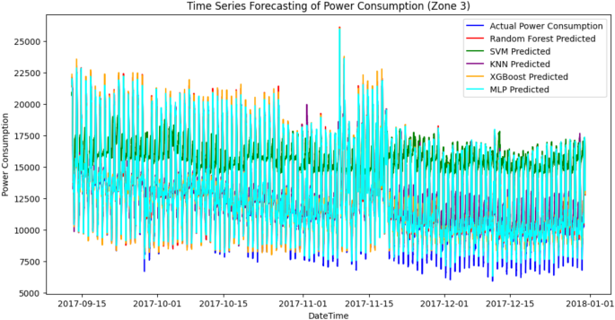

[nature.com](https://www.nature.com/articles/s41598-025-91123-8)

A hybrid time series forecasting approach integrating fuzzy ...

*A hybrid time series forecasting model (similar to the diagram above) can predict database resource needs.*

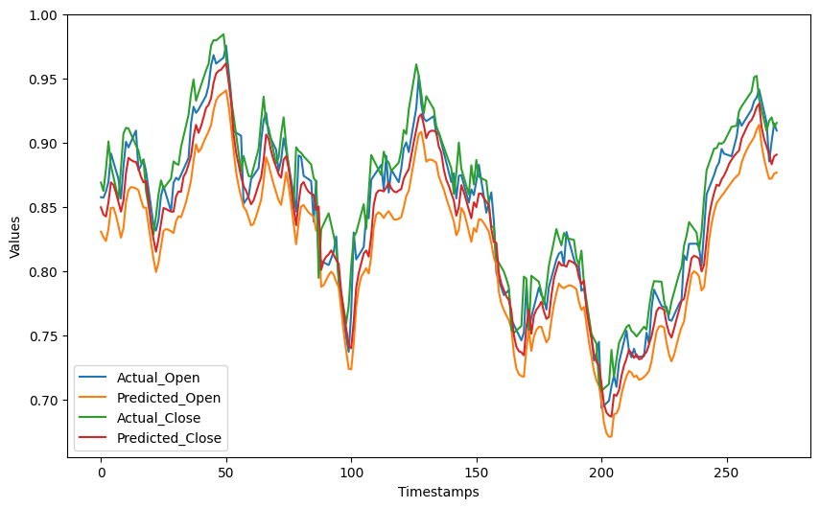

[geeksforgeeks.org](https://www.geeksforgeeks.org/machine-learning/time-series-analysis-and-forecasting/)

Time Series Analysis and Forecasting - GeeksforGeeks

AI Layer for Decision-Making and Automation (The "Blend")

1. Overlay AI (e.g., AIOps platforms) on ML outputs:
   * Generate recommendations (e.g., "Scale storage by 20% in 30 days").
   * Automate actions via orchestration (e.g., Kubernetes auto-scaling or cloud policies).

Use generative AI for natural-language reports or scenario simulations.

* + This unifies planning by integrating predictions into workflows across databases.

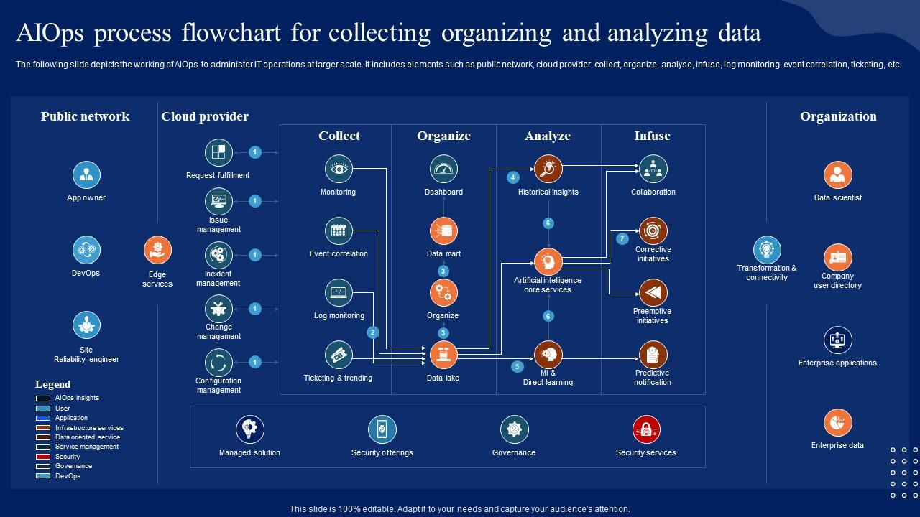

[slideteam.net](https://www.slideteam.net/aiops-process-flowchart-for-collecting-comprehensive-guide-to-begin-ai-ss-v.html)

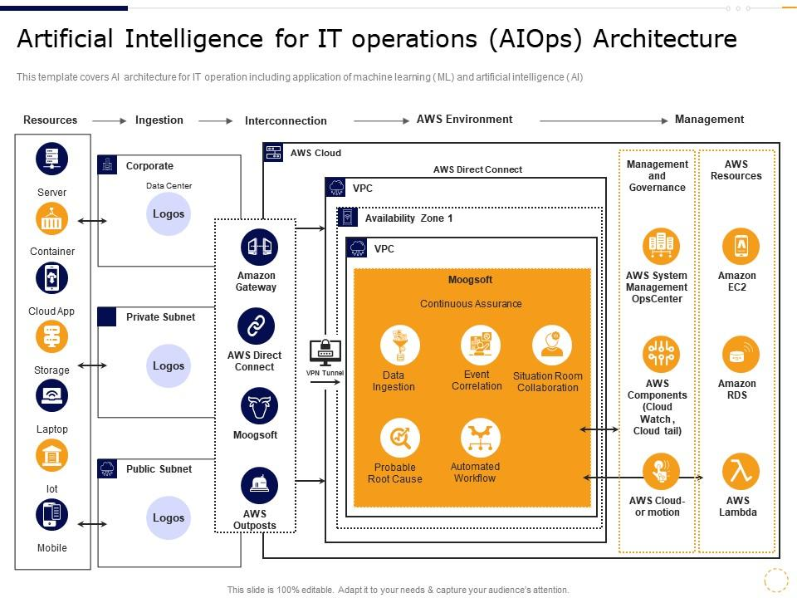

[slideteam.net](https://www.slideteam.net/artificial-intelligence-for-it-operations-aiops-architecture-devops-data-use-cases-it.html)

*AIOps flowcharts (like those above) illustrate how AI orchestrates ML insights for capacity actions.*

Deployment, Monitoring, and Iteration

1. Deploy in a loop: Retrain models periodically with new data for continuous improvement. Tools like Azure ML, AWS SageMaker, or open-source (e.g., scikit-learn, TensorFlow) support this. In unified setups, platforms like Oracle or DataBank's AI-driven tools provide dashboards for multi-database views.

#### **Tools and Real-World Examples**

* Cloud Providers → Azure/AWS/GCP use built-in ML for predictive scaling.
* AIOps Platforms → Splunk, BMC, or ServiceNow for anomaly-based planning.
* Database-Specific → Oracle Operations Insights forecasts utilization; EDB Postgres AI recommends scaling.
* Custom → Build with Python (e.g., Prophet library) on monitored metrics.

This blended approach transforms capacity planning from reactive to predictive, ensuring databases scale efficiently in unified environments. Start small with one database, then expand to a unified fleet for maximum impact.







111 sources

I want to blend AI and ML in Storage dataase capacity planning of any database which will help to prevend reducing risk and predict and prevent the required space storage and help to reduce the Service now alert related to storage, for example we are running many db instance on db server oracle as asm and other database technogies and want to predicat and forcaste how much space needed to next 3 months based on previous database and will generate the action plan to resolve the space related issue. or generate the Change orer/incident to implement the storage requried. our main goa to predict required space needed and downsize all storage db alert to zero for all database technogies. let me know how i can blend AI and ML step by step in for database storage forecast and predication. also give cople of diaggram which i can presend in my ppt

Thought for 27s

### **Blending AI and ML for Database Storage Capacity Forecasting and Prediction**

Your goal is to create a proactive system for storage capacity planning across multiple database instances (e.g., Oracle with ASM, plus other technologies like PostgreSQL, MySQL, SQL Server). This will forecast storage needs for the next 3 months based on historical data, predict risks, prevent space shortages, generate action plans (or auto-create ServiceNow changes/incidents), and ultimately drive storage-related alerts to zero by acting ahead of issues.

Machine Learning (ML) excels at analyzing historical time series data to forecast growth and detect anomalies. Artificial Intelligence (AI) (especially AIOps and generative AI) adds orchestration, decision-making, natural-language action plans, and automation (e.g., ticket creation). The blend creates a unified, predictive loop: ML predicts → AI decides and acts → Risks prevented → Alerts eliminated.

This approach works for heterogeneous environments (Oracle ASM disk groups, tablespaces in other DBs) by centralizing metrics.

#### **Step-by-Step Guide to Implementation**

Data Collection: Build a Unified Metrics Pipeline

1. Collect historical and real-time storage usage data from all databases.
   * For Oracle ASM: Query views like V$ASM_DISKGROUP, V$ASM_DISK, DBA_DATA_FILES, DBA_TABLESPACES for used/free space, growth rates.
   * For other DBs: Use equivalent queries (e.g., PostgreSQL: pg_tablespace; MySQL: information_schema.TABLES; SQL Server: sys.database_files).
   * Automate collection: Write scripts (Python/SQL) to run daily/weekly, export to a central repository (e.g., CSV, Elasticsearch, InfluxDB, or a data lake like AWS S3/Azure Data Lake).
   * Include metadata: Database name, tablespace/disk group, application owner, growth drivers (e.g., linked to app traffic logs).

Tools: Oracle Enterprise Manager (OEM), custom scripts with cx_Oracle library, or observability platforms (Prometheus + exporters).

* + Goal: Create a unified time series dataset (e.g., daily used GB per disk group/tablespace).

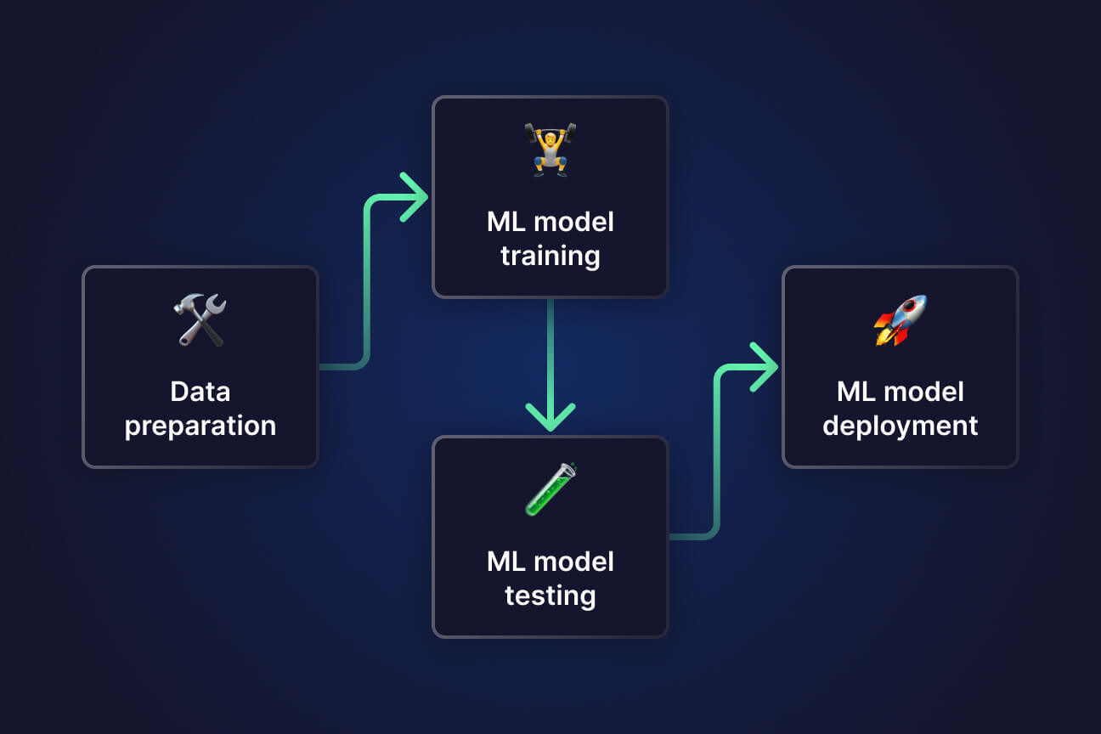

[quix.io](https://quix.io/blog/the-anatomy-of-a-machine-learning-pipeline)

The anatomy of a machine learning pipeline

*The diagram above illustrates a typical ML pipeline anatomy, which forms the foundation—adapt the "Data Ingestion" and "Feature Engineering" stages for your storage metrics.*

Data Preparation and Feature Engineering

Clean data (handle missing values, outliers).

Create time series features: Daily/weekly growth rate, moving averages, seasonality (e.g., monthly batch jobs causing spikes), external factors (e.g., business events).

Aggregate across instances for a unified view.

1. Tools: Pandas in Python for processing; store in a feature store if scaling.

ML Layer: Forecasting and Anomaly Detection

1. Train models on historical data to predict storage usage for the next 3 months (90 days).
   * Forecasting models:
     + Facebook Prophet (easy, handles trends/seasonality).
     + ARIMA/SARIMA for statistical accuracy.
     + LSTM (deep learning via TensorFlow/Keras) for complex patterns.
   * Anomaly detection: Isolation Forest or Prophet's built-in uncertainty intervals to flag unusual growth.

Output: Predictions like "Disk Group DATA will reach 95% utilization in 45 days; need +500 GB by Month 3."

Retrain models monthly with new data.

* + Example Python snippet (using Prophet):

1. Python

from prophet import Prophet

import pandas as pd

df = pd.read_csv('storage_history.csv', parse_dates=['date'])

model = Prophet(yearly_seasonality=False, weekly_seasonality=True, daily_seasonality=False)

model.fit(df)

future = model.make_future_dataframe(periods=90)

1. forecast = model.predict(future)

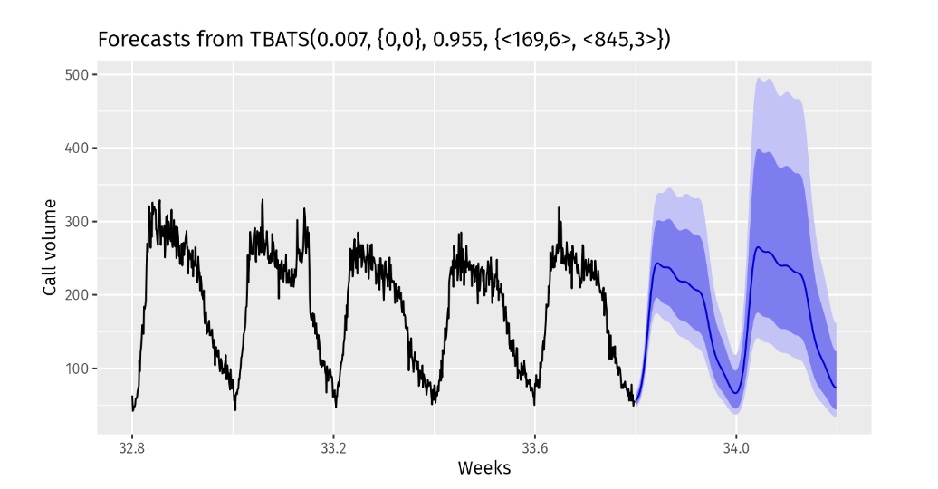

[tigerdata.com](https://www.tigerdata.com/blog/what-is-time-series-forecasting)

Time-Series Forecasting: Definition, Methods, and Applications ...

*The time series forecasting graph above shows a typical output—historical usage (blue), predicted growth (line), and confidence intervals (shaded)—perfect for visualizing 3-month storage forecasts in your PPT.*

AI Layer: Decision-Making, Action Plans, and Automation

1. Overlay AI on ML predictions:
   * Risk classification: If predicted usage > 80% threshold, flag as "High Risk."
   * Generative AI: Use an LLM (e.g., Grok, GPT via API, or open-source like Llama) to generate natural-language action plans: "Recommended: Add 1 TB to ASM Disk Group PROD_DATA via change request CR-12345 by [date]. Impact: Prevents outage for critical app."
   * Automation: Integrate with ServiceNow API to auto-create Change Requests or Incidents proactively (e.g., if risk detected, create ticket 30 days in advance).

Proactive remediation: Scripts to suggest/recommend resizing (e.g., add disks to ASM group) or data archiving.

* + Tools: LangChain for LLM orchestration; ServiceNow REST API; AIOps platforms like Splunk IT Service Intelligence or Moogsoft.

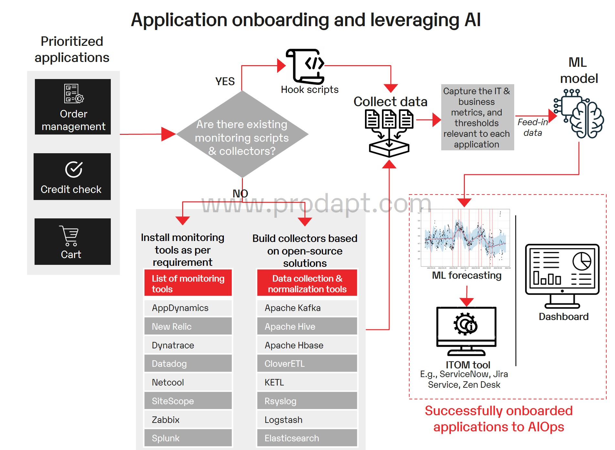

[devops.com](https://devops.com/predicting-preventing-and-resolving-incidents-with-aiops/)

Predicting, Preventing and Resolving Incidents With AIOps - DevOps.com

*The AIOps flowchart above demonstrates predicting and preventing incidents—directly aligns with your goal of reducing ServiceNow storage alerts to zero through proactive actions.*

Deployment, Monitoring, and Closed-Loop Automation

Deploy as a scheduled pipeline (e.g., Apache Airflow or cron jobs).

Build a dashboard (Grafana, Power BI, or custom Streamlit app) showing forecasts, risks, and actions across all DBs.

Set alerts only for model failures (not storage issues, since predictions prevent them).

Iterate: Monitor prediction accuracy (e.g., MAE metric); retrain as needed.

1. Outcome: Storage alerts → zero, because issues are predicted and resolved via changes/incidents before they trigger reactive alerts.

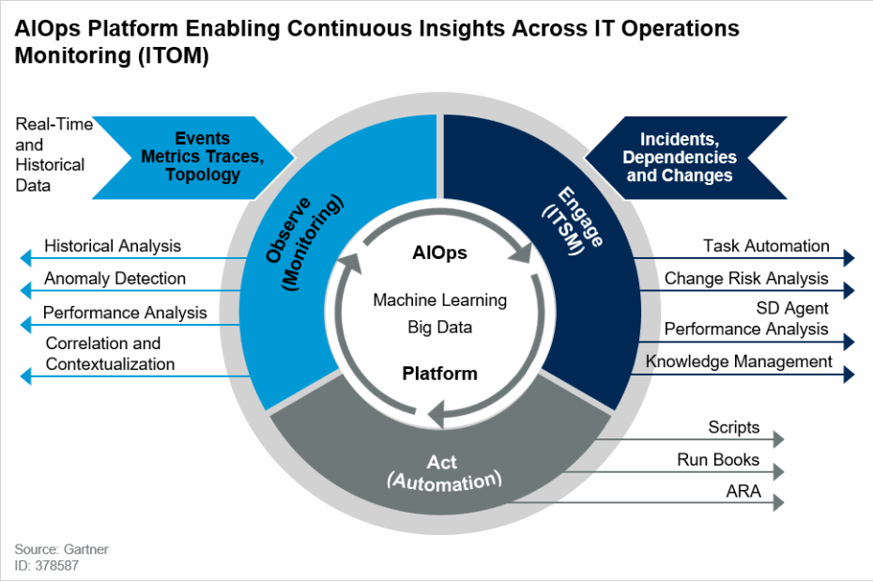

[purestorage.com](https://www.purestorage.com/knowledge/what-is-aiops.html)

What Is AIOps? Artificial Intelligence for IT Operations | Pure ...

*The AIOps architecture diagram above provides a high-level view of how AI orchestrates predictive storage management—great for showing the blended system in your presentation.*

#### **Additional Tips for Success**

* Start small: Pilot on one Oracle ASM instance, then scale to all DBs.
* Tools stack: Python (Prophet, scikit-learn), cloud ML (AWS Forecast, Azure ML) if moving to cloud, or on-prem (Oracle Machine Learning).
* Compliance: Ensure forecasts include buffers for safety; validate with DBAs.
* ROI: Track reduced incidents, avoided outages, and cost savings from right-sized storage.

This blended AI/ML system shifts you from reactive firefighting to predictive governance, achieving zero storage alerts. Implement in phases for quick wins!

20 sources

also present. based on solution it will give recomendation and ask for action to resolve the issue and update all digram accordingly

Thought for 20s

### **Enhancing the AI/ML Blend with Interactive Recommendations, Actions, and Dynamic Updates**

To achieve your goal of zero storage alerts, the system must go beyond predictions—it needs to proactively recommend solutions, prompt for actions (e.g., DBA or manager approval), execute resolutions (e.g., auto-create ServiceNow Change Requests), and dynamically update diagrams/dashboards in real-time based on actions taken. This creates a human-in-the-loop closed-loop system: ML predicts → AI recommends → User approves/executes → System updates forecasts and visuals → Loop repeats.

This interactivity reduces risks by ensuring predictions translate into timely actions, while dynamic updates keep diagrams (e.g., forecasts, risk charts) current for reporting/PPTs.

#### **Updated Step-by-Step Implementation (with Interactivity Enhancements)**

1-4. (Same as Previous: Data Collection → Preparation → ML Forecasting → AI Decision-Making)

These remain the foundation. ML generates 3-month forecasts; initial AI classifies risks and drafts recommendations.

New: Interactive Recommendation and Action Layer

1. Build an interface where the system presents predictions, gives clear recommendations, and asks for action:
   * Presentation: Dashboard/email/report shows: Forecast chart, risk level (e.g., "High: 95% utilization in 45 days"), recommended action (e.g., "Add 1 TB to ASM Disk Group DATA; Estimated cost: $X; Prevents outage").

Recommendations (powered by generative AI): Natural-language text like:

* + "Recommendation: Extend storage by 800 GB via new disks. Rationale: Based on 15% monthly growth trend. Alternative: Archive old data to free 300 GB."
  + Ask for Action: Interactive prompts, e.g.:
    - Buttons: "Approve Change Request" / "Reject" / "Modify (add notes)"
    - If approved → Auto-generate ServiceNow Change/Incident with pre-filled details (description, urgency, implementation plan).
    - If rejected/modified → Log feedback to improve future ML/AI (retrain on human overrides).
  + Tools:
    - Dashboard: Streamlit/Gradio (Python-based, quick to build) or Power BI/Tableau with interactive elements.
    - Automation: ServiceNow API for ticket creation; Slack/Teams bots for approvals.
    - Generative AI: Integrate Grok/GPT to craft personalized recommendations.



[manageengine.com](https://www.manageengine.com/it-operations-management/aiops.html)

Advanced AIOps Tool (Artificial Intelligence for IT Operations ...

*The dashboard above (from an advanced AIOps tool) shows predictive insights with recommended actions—adapt this for your storage forecasts, including "Approve" buttons for proactive resolutions.*

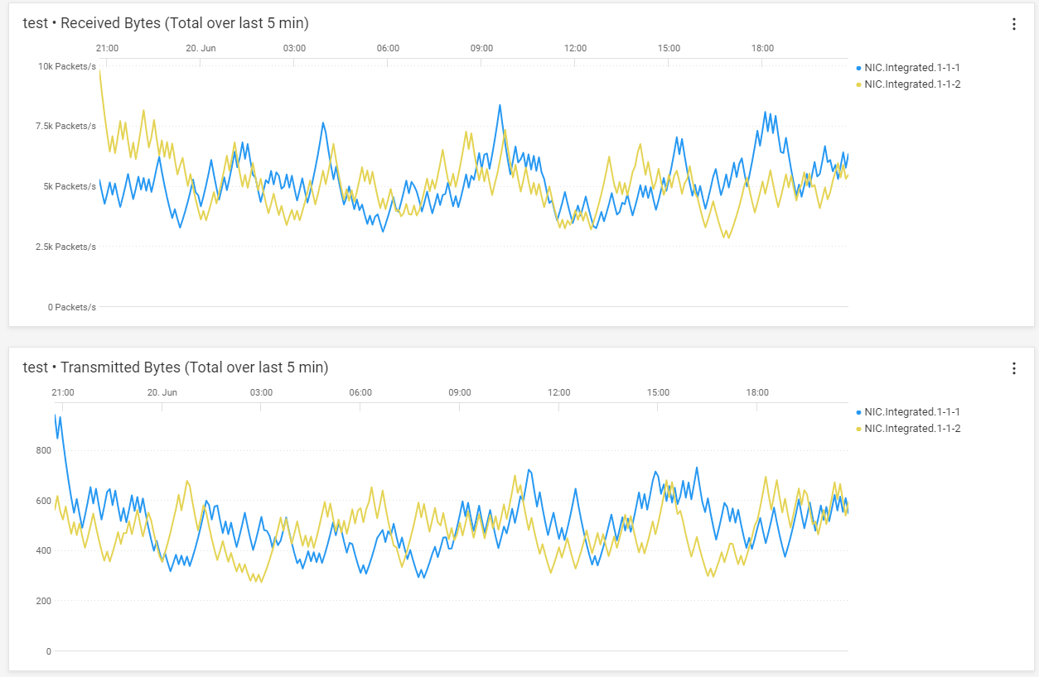

[infohub.delltechnologies.com](https://infohub.delltechnologies.com/p/apex-aiops-provides-data-driven-server-management-decisions/)

Apex AIOps Provides Data Driven Server Management Decisions | Dell ...

*This AIOps interface illustrates data-driven recommendations and decision support—perfect for presenting storage risks and prompting actions like change approvals.*

Dynamic Updates and Closed-Loop Feedback

1. After action:
   * Update forecasts immediately (e.g., simulate "what-if" with added storage).
   * Refresh all diagrams/charts in the dashboard (real-time data pull).
   * Log outcomes: If action prevents an alert, reinforce ML model; track metrics like "Alerts Reduced: 100%".

Auto-generate updated PPT slides/reports with new diagrams (e.g., via Python's pptx library or export from dashboard).

* + This ensures diagrams always reflect the latest state—no stale visuals in presentations.

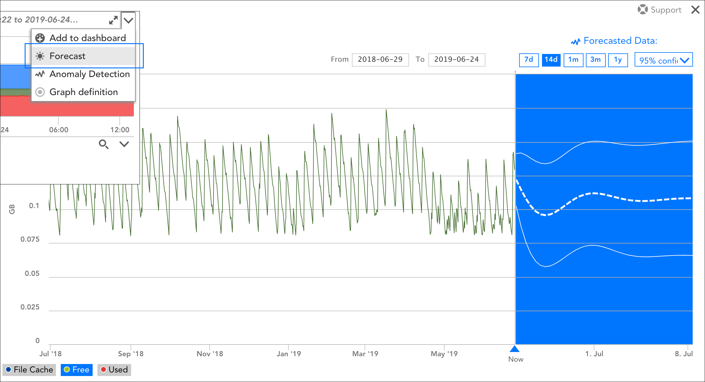

[logicmonitor.com](https://www.logicmonitor.com/support/forecasting/overview/data-forecasting-legacy-ui)

Data Forecasting | LogicMonitor

*The interactive forecasting graph above dynamically shows historical data, predictions, and thresholds—enhance yours to update post-action (e.g., new line for "After Approved Storage Addition").*

**

[researchgate.net](https://www.researchgate.net/figure/Flowchart-describing-the-pipeline-for-developing-an-AI-solution-for-a-beamline-science_fig1_360750509)

Flowchart describing the pipeline for developing an AI solution ...

*This updated flowchart represents the full closed-loop: Predictions → Recommendations → Action Approval → Execution → Feedback/Update—core to your interactive system.*

**

[aws.amazon.com](https://aws.amazon.com/blogs/machine-learning/build-an-automated-generative-ai-solution-evaluation-pipeline-with-amazon-nova/)

Build an automated generative AI solution evaluation pipeline with ...

*The architecture diagram above shows an AI pipeline with evaluation and automation—mirrors your enhanced flow, including recommendation engines and dynamic loops for storage planning.*

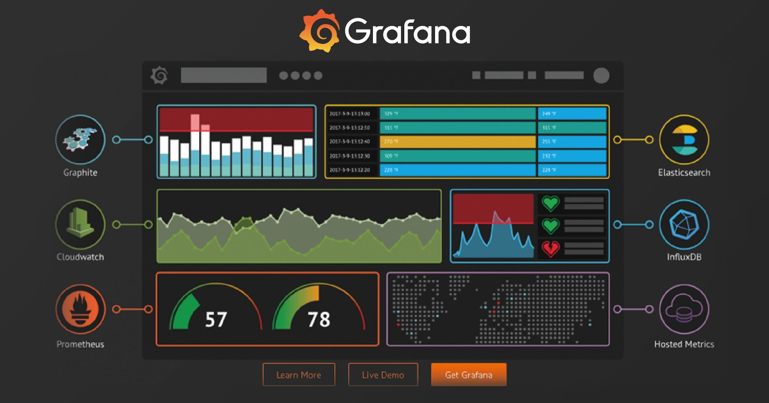

[mysoly.nl](https://mysoly.nl/visualization-and-monitoring-with-grafana-an-introductory-guide/)

Visualization and Monitoring with Grafana: An Introductory Guide

*This monitoring dashboard example can be customized for your use case, with real-time updates to forecasts and action statuses across all database instances.*

#### **Example Workflow in Action**

* System runs daily → Detects risk in Oracle ASM group.
* Dashboard notifies: Forecast chart + Recommendation: "Add 500 GB by Feb 20, 2026."
* Prompts: "Approve auto-creation of Change Request CHG001234?"
* You click Approve → Ticket created in ServiceNow → Storage added → Forecast updates (risk drops to green) → Diagrams refresh → No alert fires.

This interactive blend ensures recommendations are actionable, risks are resolved proactively, and diagrams stay current—driving storage alerts to zero while providing auditable trails. For your PPT, use these diagrams to showcase the "before reactive" vs. "after proactive interactive" states. Implement the dashboard first for immediate impact!

30 sources

Example Workflow in Action

* System runs daily → Detects risk in Oracle ASM group.
* Dashboard notifies: Forecast chart + Recommendation: "Add 500 GB by Feb 20, 2026."
* Prompts: "Approve auto-creation of Change Request CHG001234?"
* You click Approve → Ticket created in ServiceNow → Storage added → Forecast updates (risk drops to green) → Diagrams refresh → No alert fires. also add if anomly dedected in database objects growth, email should be send out to application owner to review it.

Thought for 23s

### **Updated AI/ML Blend: Adding Object-Level Anomaly Detection with Email Notifications**

To further proactively reduce risks and drive storage alerts to zero, enhance the system with granular anomaly detection at the database object level (e.g., specific tables, indexes, partitions, or tablespaces in Oracle ASM/other DBs). This identifies unusual growth patterns (e.g., a table suddenly ballooning due to application bugs, unoptimized loads, or data retention issues) early—often the root cause of overall storage spikes.

ML handles anomaly detection on per-object time series data.

AI triggers targeted notifications: Send automated emails to the application owner (mapped via metadata, e.g., from CMDB or a simple owner table) with details and review prompts. This complements overall forecasts by enabling faster, targeted interventions (e.g., data archiving, partitioning, or query fixes) before they escalate to capacity issues.

This keeps the system unified: Object anomalies feed into overall forecasts, and resolutions update predictions dynamically.

#### **Key Enhancements to the Implementation**

Data Collection (Updated): Extend metrics to object-level granularity.

* Query views like Oracle's DBA_SEGMENTS (for table/index sizes), DBA_TABLESPACES, or equivalents in other DBs. Track daily sizes per object (filter top growers).

ML Layer (Enhanced for Anomalies):

* Apply anomaly detection models per object (or groups):
  + Algorithms: Prophet (with uncertainty), Isolation Forest, or autoencoders for multivariate.
  + Flag anomalies: E.g., growth > 3σ from baseline, or sudden spikes.
  + Integrate with forecasts: Anomalies adjust 3-month predictions (e.g., accelerate projected utilization).

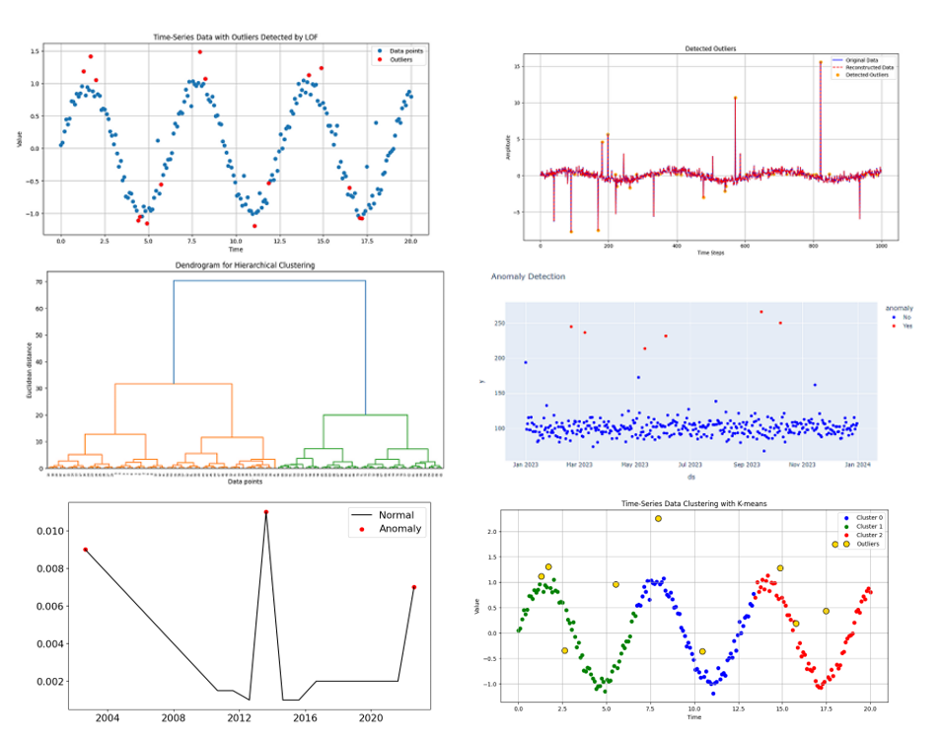

[medium.com](https://medium.com/data-science/the-ultimate-guide-to-finding-outliers-in-your-time-series-data-part-2-674c25837f29)

The Ultimate Guide to Finding Outliers in Your Time-Series Data ...

*The time series graph above highlights detected outliers/anomalies in growth data—adapt this for visualizing object-level spikes (e.g., a table's sudden size increase).*

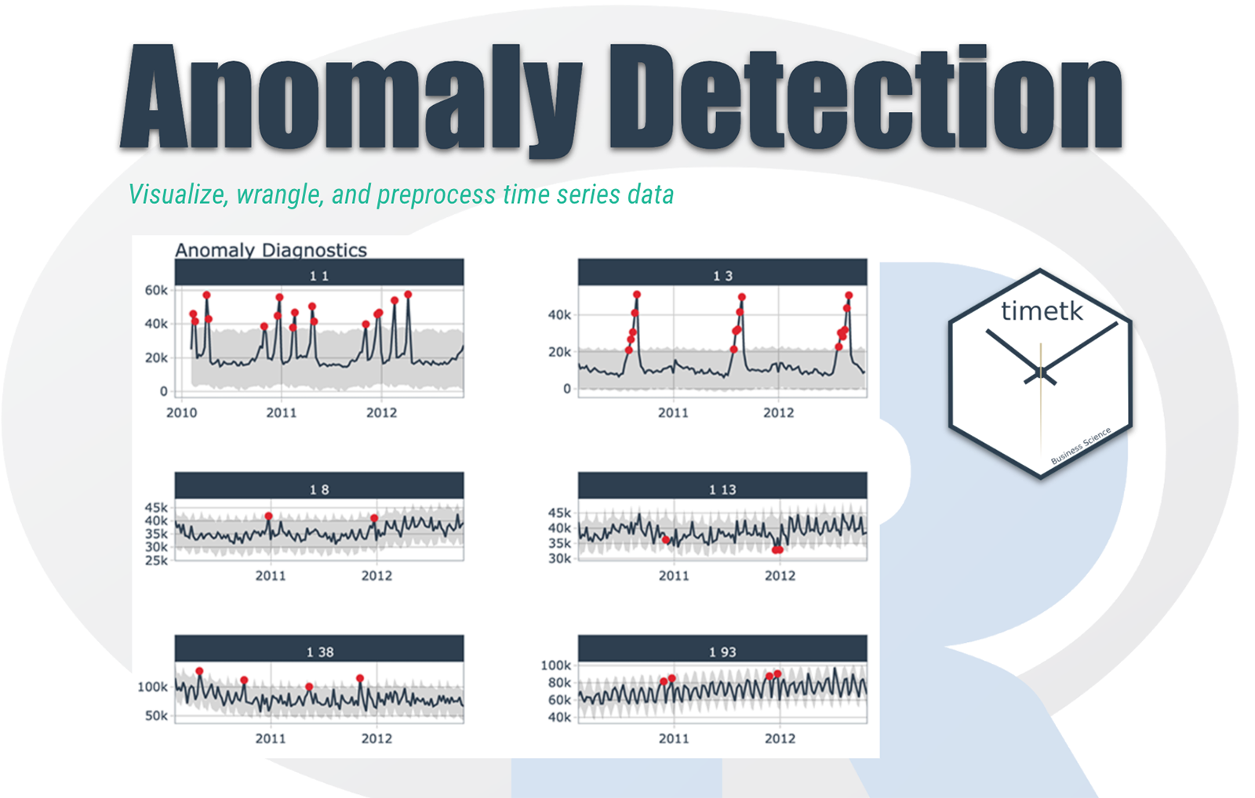

[r-bloggers.com](https://www.r-bloggers.com/2020/09/time-series-in-5-minutes-part-5-anomaly-detection/)

Time Series in 5-Minutes, Part 5: Anomaly Detection | R-bloggers

*This anomaly detection visualization shows flagged points in a time series—ideal for PPT slides demonstrating how the system spots unusual database object growth.*

AI/Action Layer (New Notification Workflow):

* If anomaly detected:

Generative AI crafts personalized email: Subject: "Anomaly Detected: Unusual Growth in [OBJECT_NAME]"

* + Body: "Table [TABLE_X] in [DB_INSTANCE] grew +150% last week (from 50 GB to 125 GB). Expected baseline: +5%. Potential causes: Data load, missing purge. Please review and advise actions (e.g., archive, optimize). Link to dashboard for details."
  + Send via SMTP integration (e.g., Python smtplib, or tools like SendGrid/API).
  + Include dashboard link and "what-if" suggestions (e.g., "Archiving partitions could free 40 GB").

Log response: If owner replies/confirms fix, update system (retrain ML on resolved case).

* + Combine with dashboard prompts for high-severity anomalies (e.g., escalate to Change Request).

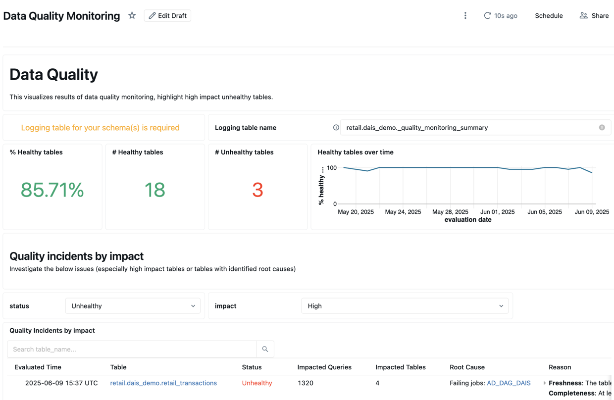

[docs.databricks.com](https://docs.databricks.com/gcp/en/data-quality-monitoring/anomaly-detection/)

Anomaly detection | Databricks on Google Cloud

*The monitoring dashboard above shows anomaly alerts with schema/object details—customize yours to highlight flagged tables and trigger email buttons.*

* Closed-Loop Updates: Post-review/fix (e.g., owner cleans data), refresh forecasts, clear anomaly flags, and update all diagrams dynamically.

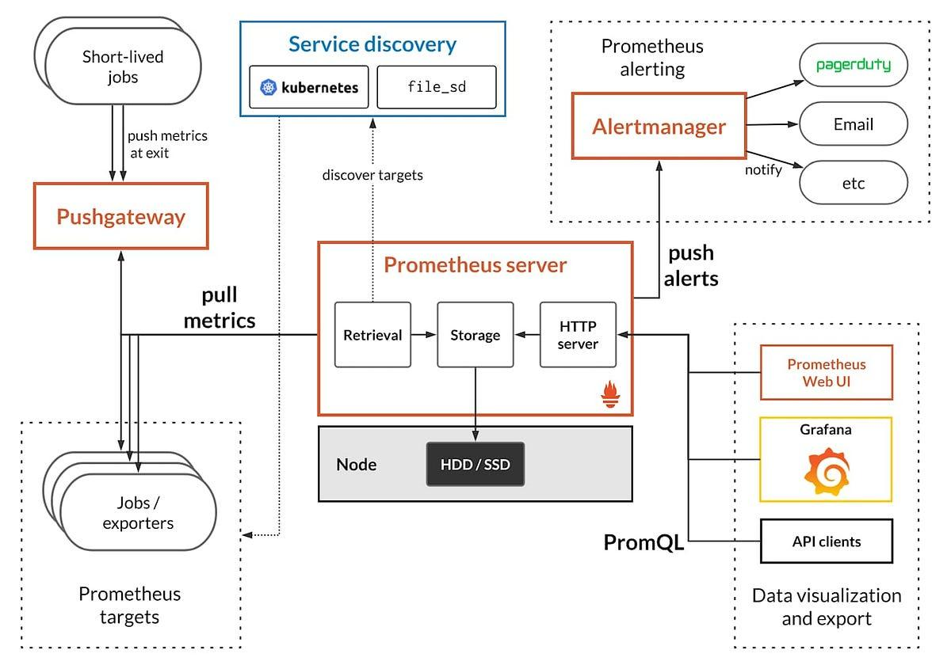

[ai.plainenglish.io](https://ai.plainenglish.io/aiops-the-complete-architecture-unpacked-from-raw-data-to-intelligent-automation-0b0de4ff08ea)

AIOps: The Complete Architecture Unpacked — From Raw Data to ...

*This comprehensive AIOps architecture diagram includes anomaly detection, alerting/notifications, and automation loops—perfect for illustrating the enhanced flow with email triggers.*

#### **Updated Example Workflow in Action (with Anomaly Branch)**

The system runs daily (or more frequently for objects) across all DB instances:

1. Overall Storage Risk Path (as before):
   * Detects risk in Oracle ASM group (e.g., projected 95% utilization).
   * Dashboard notifies: Forecast chart + Recommendation: "Add 500 GB by Feb 20, 2026."
   * Prompts: "Approve auto-creation of Change Request CHG001234?"
   * You click Approve → Ticket created in ServiceNow → Storage added → Forecast updates (risk drops to green) → Diagrams refresh → No alert fires.
2. New: Object-Level Anomaly Path (parallel or triggering overall risk):
   * Detects anomaly: E.g., Table APP_LOG in PROD_DB grew abnormally (+200% in 7 days, vs. historical 5%).

System flags it → Generative AI drafts and sends email automatically to application owner (e.g., appowner@company.com):

"Alert: Anomaly in Database Object Growth

Details: Table APP_LOG (Owner: Your Team) unexpected spike.

Recommendation: Review for cleanup/purge jobs. Potential savings: 100 GB if archived.

* + Dashboard Link: [URL] – Reply to this email with actions taken."
  + Owner reviews/fixes (e.g., runs purge) → Data reflects in next run → Anomaly cleared → Overall forecast improves → No escalation to capacity alert.

These paths integrate: An unresolved object anomaly accelerates overall risk predictions, prioritizing it in the dashboard.

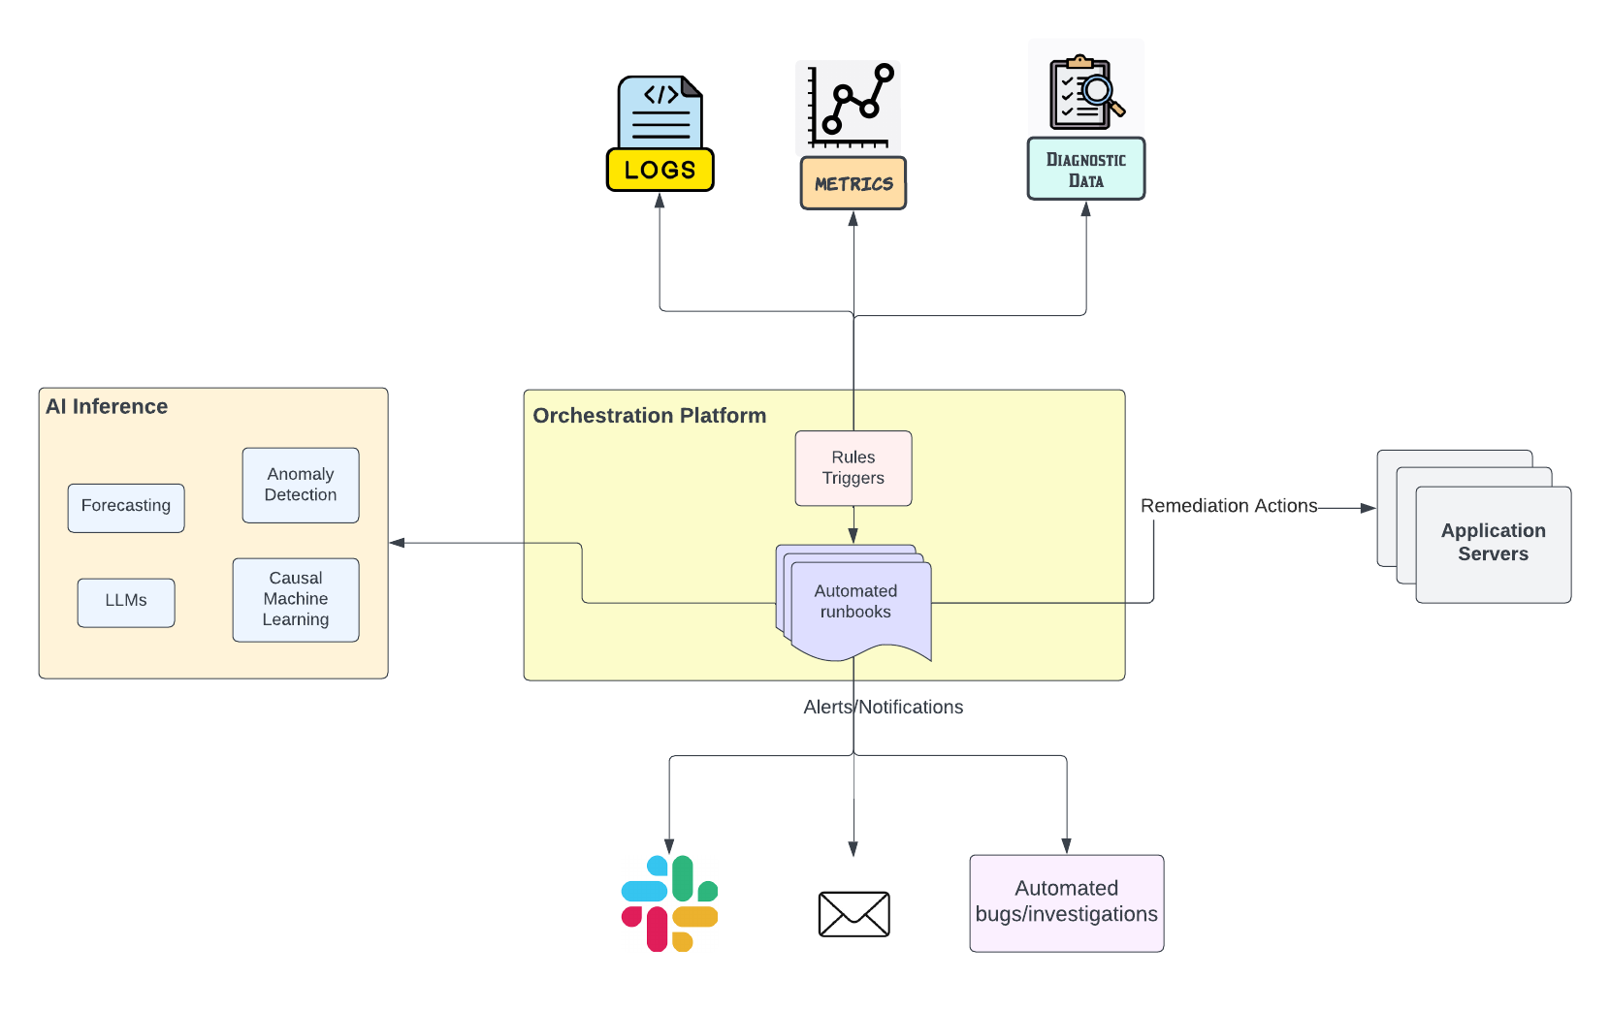

[engineering.salesforce.com](https://engineering.salesforce.com/aiops-engineering-secrets-revealed-how-ai-and-automation-slash-thousands-of-manual-hours-annually/)

AIOps: How AI and Automation Slash Thousands of Manual Hours Annually

*This AIOps workflow diagram captures detection, recommendations, notifications (including emails), and resolution—directly maps to your dual-path system for storage and object anomalies.*

**

[safeaeon.com](https://www.safeaeon.com/security-blog/AIOps/)

AIOps: How AI Transforms IT Operations and Security

*The high-level AIOps process flow above shows how anomalies lead to targeted alerts and actions—use this to depict the email notification branch in your PPT.*

This addition makes the system even more proactive: Catch issues at the source (objects) via emails, prevent propagation to storage crises, and maintain zero alerts. For PPT, these diagrams contrast "reactive alerts" vs. "proactive emails + changes." Start by adding object queries to your data pipeline!

24 sources

give more digrarm on this which represennts. predict and prevent and downsize the tickets and take action after recomentation after leadership team approval. using data to predict issues, prevent failures an dmaking system more reliable, secure and resilent and ensure repid recovery while reducting risks relatated to outages breaches and vulnerabilities

Thought for 24s

### **Expanding the AI/ML System: Predict, Prevent, Reduce Tickets, and Build Resilience with Approval Gates**

Your AI/ML blended solution for database storage capacity planning not only forecasts needs and prevents space shortages but also contributes to broader IT goals: Using data-driven predictions to prevent failures/outages, downsize ServiceNow tickets/alerts to near-zero, act only after recommendations and leadership approvals, and make systems more reliable, secure, resilient, with rapid recovery from potential issues. This reduces risks from outages (e.g., storage exhaustion causing app downtime), vulnerabilities (e.g., anomaly detection spotting unusual patterns that could indicate breaches), and overall operational disruptions.

By shifting from reactive (firefighting alerts) to proactive (predict → recommend → approve → act), the system minimizes incidents, ensures controlled actions (especially for costly storage additions), and reinforces resilience through continuous learning and feedback loops.

#### **Enhanced Workflow with Leadership Approval**

Update the closed-loop to include approval gates:

* ML predicts risk/anomaly.
* AI generates recommendation (e.g., "Add 1 TB – Estimated cost: $5K").
* For low-risk (e.g., minor archiving) → Auto-action or DBA approval.
* For high-risk/major impact (e.g., large storage add, potential cost/outage aversion) → Route to leadership team for review/approval via dashboard notification, email, or ServiceNow workflow.

Post-approval → Auto-create Change Request → Execute → Update forecasts → Reduce future risks.

* This ensures governance while maintaining speed.

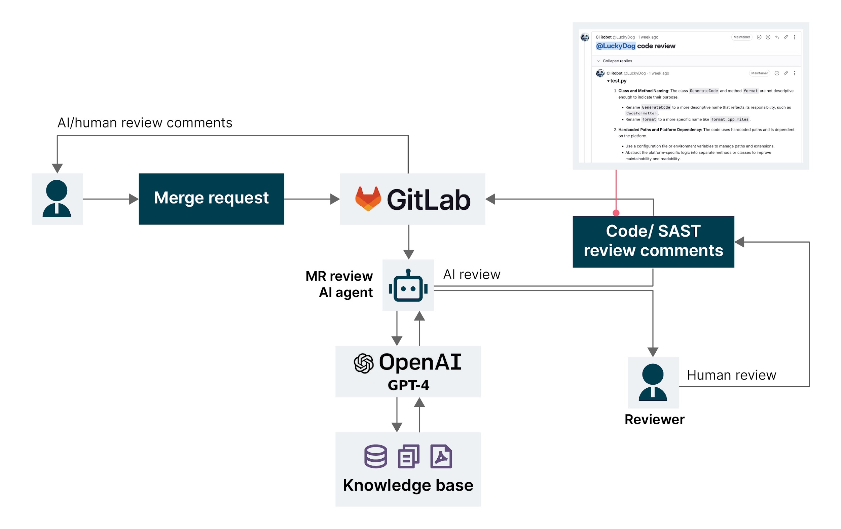

[thoughtworks.com](https://www.thoughtworks.com/en-us/insights/articles/how-ai-is-reshaping-it-operations)

How AI is reshaping IT operations: From firefighting to ...

*The diagram above shows how AI reshapes IT operations from reactive to proactive, with prediction, automation, and human oversight—aligns perfectly with your approval gate for leadership review before major actions.*

**

[cisco.com](https://www.cisco.com/c/en/us/support/docs/cloud-systems-management/crosswork-network-controller/221798-understand-close-loop-automation-in-clou.html)

Understand Close Loop Automation in Cloud Based Software Defined ...

*This closed-loop automation flowchart illustrates detection → analysis → recommendation → approval → action → feedback, ideal for representing your system's leadership-gated execution to prevent unapproved changes.*

#### **Key Diagrams for Your PPT: Predict, Prevent, and Ticket Reduction**

Here are additional professional diagrams visualizing the core concepts. Use them to contrast "before" (reactive, high tickets) vs. "after" (predictive, zero alerts, resilient operations).

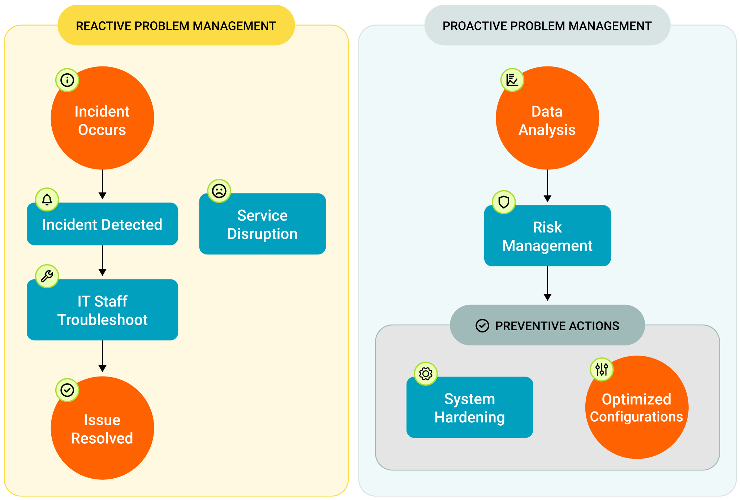

[solarwinds.com](https://www.solarwinds.com/itsm-best-practices)

ITSM Best Practices: Flow Charts & Examples - IT Guide | SolarWinds

*This reactive vs. proactive problem management diagram highlights how predictive AI/ML shifts from high-volume tickets/alerts (reactive firefighting) to prevention—directly shows downsizing ServiceNow storage incidents to zero.*

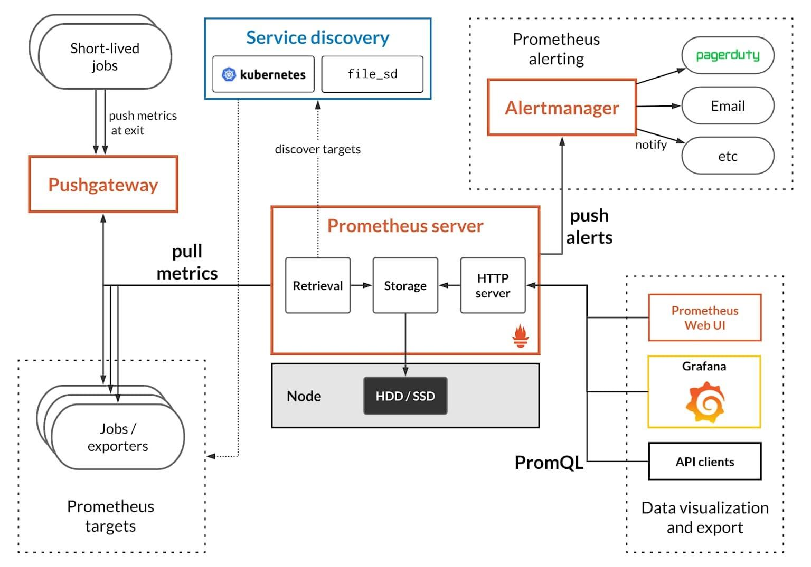

[ai.plainenglish.io](https://ai.plainenglish.io/aiops-the-complete-architecture-unpacked-from-raw-data-to-intelligent-automation-0b0de4ff08ea)

AIOps: The Complete Architecture Unpacked — From Raw Data to ...

*The comprehensive AIOps architecture above unpacks data ingestion → ML prediction → AI recommendations → automated/preventive actions, representing your full predict-and-prevent cycle for storage risks.*

**

[healsoftware.ai](https://healsoftware.ai/blog/ai-powered-it-resilience-faster-recovery-lower-costs.html)

AI-Powered IT Resilience: Faster Recovery, Lower Costs

*This AI-powered IT resilience visual demonstrates faster recovery and lower costs through proactive prevention—ties to reducing outage risks, ensuring rapid recovery, and building overall system reliability.*

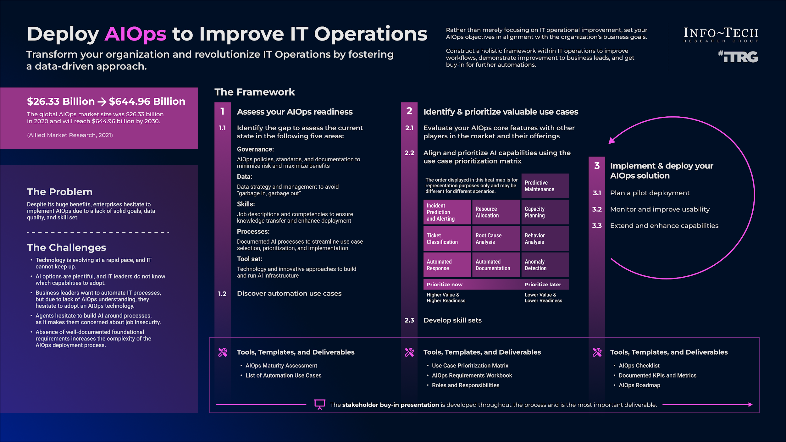

[infotech.com](https://www.infotech.com/research/ss/deploy-aiops-to-improve-it-operations)

Deploy AIOps to Improve IT Operations | Info-Tech Research Group

*The AIOps deployment roadmap above shows stages from monitoring to intelligent automation with human-in-the-loop approvals—great for illustrating leadership-gated actions post-recommendation.*

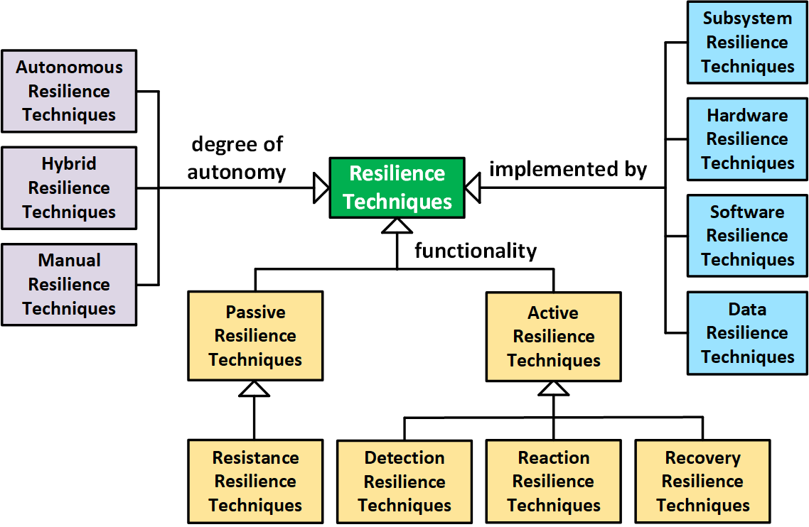

[sei.cmu.edu](https://www.sei.cmu.edu/blog/system-resilience-part-4-classifying-system-resilience-techniques/)

System Resilience Part 4: Classifying System Resilience Techniques

*This system resilience classification diagram outlines techniques for prediction, prevention, and recovery—maps to making your databases more resilient against outages, vulnerabilities, and failures via data-driven insights.*

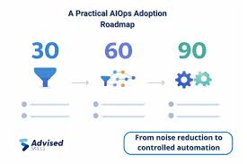

[advisedskills.com](https://www.advisedskills.com/blog/artificial-intelligence-ai/aiops-from-zero-when-monitoring-stops-being-enough-and-how-to-prepare-your-data-for-operations-automation)

AIOps From Zero: When Monitoring Stops Being Enough and How to ...

*The practical AIOps adoption roadmap provides a step-by-step view of moving to predictive operations, reducing risks, and enhancing security/resilience—use this to show the journey to zero storage alerts.*

These diagrams reinforce your narrative: Data predicts issues → AI recommends → Leadership approves → Actions prevent failures → Tickets plummet → Systems become reliable, secure, and resilient. For PPT, pair them with your specific storage forecast examples. This approach not only solves capacity planning but elevates overall IT maturity! If needed, we can refine the approval logic further.

48 sources

give me attactive idea name which can impact largly for database storage capactity planning and prediction using AI and ml and object anomly detection a recomentation

### **Attractive Project Name Ideas for AI/ML-Driven Database Storage Capacity Planning**

Here are some compelling, memorable name suggestions for your initiative. Each is designed to be professional yet impactful—evoking innovation, proactivity, prevention, and transformation. They highlight the core strengths: AI/ML forecasting, object-level anomaly detection, smart recommendations, risk prevention, and driving alerts/tickets to zero while building resilience.

1. StorSentinel AI
   * *Why it impacts*: "Sentinel" conveys vigilant guardianship—predicting threats, detecting anomalies early, and preventing outages. Positions your solution as an always-watchful protector that eliminates reactive tickets and ensures resilient, zero-downtime databases.
2. CapaciForge
   * *Why it impacts*: Combines "Capacity" with "Forge" (building something strong and future-proof). Suggests forging intelligent, predictive storage strategies with AI/ML, proactively shaping the future while reducing risks and incidents dramatically.
3. PredictGuard
   * *Why it impacts*: Straightforward yet powerful—emphasizes prediction + protection. Highlights anomaly detection, 3-month forecasting, and recommendation-driven actions that guard against space crises, slashing tickets and boosting reliability.
4. IntelliSpace Horizon
   * *Why it impacts*: "IntelliSpace" nods to intelligent storage management; "Horizon" evokes forward-looking 3-month+ predictions. Conveys a visionary tool that scans the horizon for anomalies and risks, enabling proactive leadership-approved actions for resilient systems.
5. AnomZero Predictor
   * *Why it impacts*: Directly ties to your goal of zero alerts/tickets ("Zero") with built-in anomaly detection ("Anom"). Sounds bold and results-oriented—promises total prevention of storage failures through AI recommendations and rapid recovery.
6. DB Vanguard AI
   * *Why it impacts*: "Vanguard" means leading the charge—positions your solution as the forefront of database innovation. Stresses leading with predictions, anomaly alerts to owners, and gated approvals to prevent outages, breaches, and vulnerabilities.
7. ResilientForge DB
   * *Why it impacts*: Focuses on building resilience (your broader goal) while "Forge" implies crafting robust, predictive capacity plans. Evokes strength against risks, with ML anomaly detection and AI recommendations ensuring secure, rapid-recovery databases.
8. SmartShield Capacity
   * *Why it impacts*: "SmartShield" combines AI intelligence with defensive protection. Perfect for showcasing how the system shields databases from space shortages via object-level insights, proactive emails/changes, and leadership-gated actions—driving massive ticket reduction.
9. ForeSight Anomaly AI
   * *Why it impacts*: "ForeSight" directly references predictive forecasting; paired with "Anomaly" for granular detection. Creates a sense of clairvoyance—foreseeing issues, recommending fixes, and preventing failures for highly reliable operations.
10. ZeroRisk Storage Oracle
    * *Why it impacts*: "Oracle" cleverly nods to Oracle databases while meaning prophetic wisdom. "ZeroRisk" boldly claims the end goal—eliminating outage/breach risks through ML predictions, anomaly emails, and approved recommendations.

Recommendation: Go with StorSentinel AI or PredictGuard for maximum appeal—they're short, brandable, and instantly communicate proactivity and prevention. These names can become your project's identity in PPTs, dashboards, or even a tool name, making it easier to gain leadership buy-in and showcase large-scale impact (e.g., "StorSentinel reduced storage incidents by 100%"). If you share more details (e.g., company branding), I can refine further!

I want to keep database capacity and add more words to transform idea which will use AI and ml and data engineering

### **Transformed Project Name Ideas: Emphasizing AI, ML, and Data Engineering for Database Capacity Mastery**

To elevate your initiative, I've refined the naming concepts to retain "Database Capacity" as a core element (for clarity and SEO/recognizability) while adding transformative words that highlight AI-driven intelligence, ML-powered predictions, data engineering pipelines, and the broader impact: proactive prevention, anomaly detection, zero alerts, resilience, and leadership-gated actions.

These names position the project as a holistic, cutting-edge transformation—not just planning, but an intelligent ecosystem that engineers data for predictive supremacy, prevents outages, and optimizes costs at scale.

1. Database Capacity Intelligence Engine (DCIE)
   * *Transformative impact*: "Intelligence Engine" evokes a powerful AI/ML core fueled by data engineering pipelines. Suggests an automated "engine" that ingests, processes, and predicts—transforming raw metrics into actionable foresight for zero-risk databases.
2. AI/ML Database Capacity Forge
   * *Transformative impact*: Keeps "Database Capacity" central; "Forge" implies data engineering craftsmanship + AI/ML forging resilient futures. Conveys building unbreakable capacity strategies through predictive modeling and anomaly-driven recommendations.
3. DataEngine Predict: Database Capacity AI
   * *Transformative impact*: Leads with "DataEngine" to spotlight data engineering (pipelines, ETL, unification); "Predict" emphasizes ML forecasting. Positions it as a predictive powerhouse that engineers data for AI recommendations and preventive actions.
4. Quantum Database Capacity Sentinel
   * *Transformative impact*: "Quantum" adds a futuristic, transformative leap (AI/ML + data engineering at scale); "Sentinel" retains vigilant protection. Implies quantum-level insights from engineered data streams, detecting anomalies and preventing failures proactively.
5. Database Capacity Nexus AI/ML
   * *Transformative impact*: "Nexus" represents the unified hub where data engineering converges disparate sources, AI orchestrates recommendations, and ML predicts 3-month horizons—transforming silos into a resilient, interconnected capacity ecosystem.
6. IntelliFlow Database Capacity Predictor
   * *Transformative impact*: "IntelliFlow" highlights intelligent data engineering flows (pipelines) + AI/ML fluidity. Suggests seamless, flowing predictions that prevent bottlenecks, reduce tickets, and enable rapid, approved recoveries.
7. Database Capacity Resilience Orchestrator (DCRO)
   * *Transformative impact*: "Resilience Orchestrator" transforms the idea into an AI conductor, using ML predictions and data engineering to orchestrate preventive actions, leadership approvals, and anomaly resolutions for unbreakable databases.
8. Apex Database Capacity DataForge
   * *Transformative impact*: "Apex" for peak performance; "DataForge" merges data engineering (forging clean pipelines) with AI/ML (apex predictions). Evokes reaching the pinnacle of capacity management—zero outages, secure, and resilient.
9. Database Capacity Vanguard: AI/ML Data Engineered
   * *Transformative impact*: Full phrase as a title/tagline; "Vanguard" for leadership in innovation, explicitly calling out "AI/ML Data Engineered" to showcase the tech stack. Transforms it into a forward-guard system preventing risks at the data foundation.
10. Synergy Database Capacity AI Platform
    * *Transformative impact*: "Synergy" captures the blend of data engineering (unified ingestion), ML (forecasting/anomalies), and AI (recommendations/orchestration). Positions it as a synergistic platform transforming reactive ops into predictive excellence.

Top Recommendation: Database Capacity Intelligence Engine (DCIE) or DataEngine Predict: Database Capacity AI—they're memorable, acronym-friendly, and directly searchable while sounding highly transformative. Use as the main title, with a tagline like:

*"Powered by AI, ML, and Data Engineering: Predict Anomalies, Prevent Outages, Achieve Zero Alerts."*

These will make your PPT and stakeholder presentations stand out, emphasizing the large-scale transformation from manual monitoring to an intelligent, engineered system. If you'd like logos concepts, taglines, or a full vision statement, let me know!

where I can use chatgpt API here and how it will help give me all points and give full digram with all componects and echo system to build the solution

Thought for 18s

### **Integrating ChatGPT API (OpenAI GPT Models) into Your Database Capacity Intelligence Engine**

The ChatGPT API (OpenAI's API for models like GPT-4o, GPT-4 Turbo) serves as the generative AI layer in your blended AI/ML + data engineering solution. It transforms raw ML outputs (e.g., forecasts, anomaly flags) into human-friendly, actionable content—making the system more intuitive, efficient, and adoptable.

Integrate it via simple API calls (Python's openai library) in your pipeline (e.g., Apache Airflow tasks or Flask/Streamlit backend). Use it sparingly for cost control (e.g., only on high-risk predictions) and cache responses.

#### **Key Places to Use ChatGPT API and How It Helps**

1. Generating Natural-Language Recommendations & Action Plans
   * Where: After ML forecasting/anomaly detection (e.g., Prophet/LSTM output: "Need +500 GB in 45 days").
   * How it helps: Prompt GPT to convert structured data into detailed, contextual plans: "Recommendation: Add 1 TB to ASM Disk Group PROD_DATA by Feb 20, 2026. Rationale: 18% monthly growth from historical trends. Alternatives: Archive partitions (save 300 GB). Impact: Prevents outage for critical app; estimated cost $4K."
   * Benefits: Saves DBA time on manual writing; ensures consistent, professional tone; includes rationale for leadership approvals.
2. Crafting Personalized Emails for Object-Level Anomalies
   * Where: In the anomaly notification branch (e.g., table spike detected).
   * How it helps: Feed anomaly details + owner metadata to GPT: Generate emails like "Table APP_LOG grew +200% unexpectedly—potential data load issue. Please review purge jobs. Dashboard link: [URL]."
   * Benefits: Targeted, polite communication increases owner response rate; reduces escalation to tickets; catches issues early for zero alerts.
3. Auto-Generating ServiceNow Change Requests/Incidents
   * Where: Post-approval gate (after leadership review).
   * How it helps: GPT fills ticket fields: Detailed description, urgency, steps, business impact.
   * Benefits: Speeds proactive ticket creation; ensures complete, auditable records; minimizes human errors.
4. Executive Summaries & Leadership Approval Prompts
   * Where: Dashboard notifications or approval workflow.
   * How it helps: Summarize risks: "High-risk forecast for 3 DBs; total additional storage needed: 2.5 TB by Q2 2026. Approval required for changes totaling $15K."
   * Benefits: Simplifies decision-making for non-technical leaders; justifies actions with clear ROI (e.g., "Prevents $50K outage cost").
5. Natural-Language Dashboard Interface & Queries
   * Where: Frontend (Streamlit/Power BI with chat widget).
   * How it helps: Users ask "Show 3-month forecast for Oracle PROD" → GPT interprets query, pulls data, responds conversationally with charts.
   * Benefits: Democratizes access (no SQL needed); improves user adoption.
6. What-If Scenario Simulations & Explanations
   * Where: Dashboard or reports.
   * How it helps: Simulate "If we archive 500 GB, new forecast?" → GPT explains updated predictions in plain English.
   * Benefits: Supports better planning; explains ML "black box" (e.g., "Growth driven by seasonal batches").
7. Report Generation & Anomaly Root-Cause Hypotheses
   * Where: Scheduled reports or post-resolution feedback.
   * How it helps: Generate monthly PDFs/slides: "Storage trends summary + prevented incidents." Or hypothesize: "Anomaly likely from unoptimized ETL job."
   * Benefits: Automates reporting; aids troubleshooting; tracks ROI (e.g., "Reduced tickets by 95%").

Overall Advantages: Lowers operational effort, boosts proactivity, enhances resilience (faster recovery via clear actions), and scales the system—turning data into narratives that drive zero alerts and leadership buy-in.

#### **Full Ecosystem Diagram: Components and Architecture**

The ecosystem includes: Data sources → Engineering pipelines → ML core → GPT API orchestration → Outputs (dashboard, emails, tickets) → Feedback loop.

Here are comprehensive diagrams visualizing the integrated solution (with GPT as the generative layer for recommendations, emails, and actions).

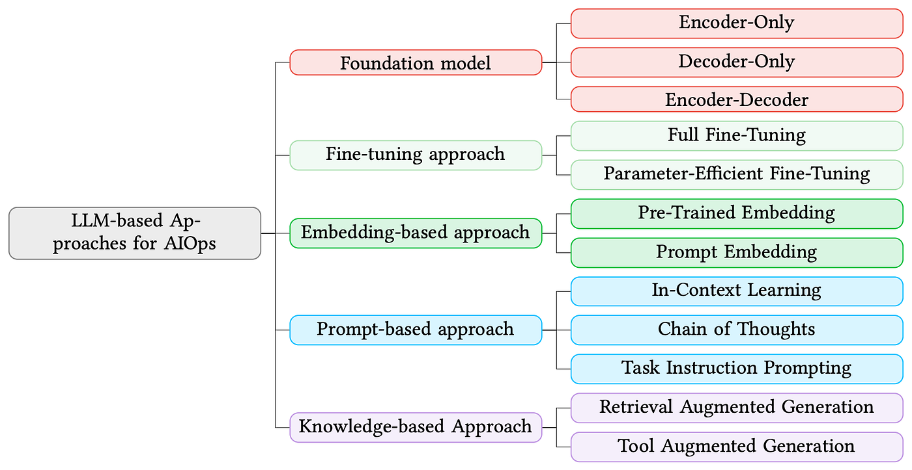

[blog.gopenai.com](https://blog.gopenai.com/the-aiops-revolution-how-llms-are-transforming-it-operations-from-reactive-to-autonomous-6ca33244f013)

The AIOps Revolution: How LLMs Are Transforming IT Operations From ...

*The diagram above shows AIOps transformation with LLMs (like ChatGPT API)—perfect for your proactive shift, including prediction, anomaly handling, recommendations, and automation.*

**

[ai.plainenglish.io](https://ai.plainenglish.io/aiops-the-complete-architecture-unpacked-from-raw-data-to-intelligent-automation-0b0de4ff08ea)

AIOps: The Complete Architecture Unpacked — From Raw Data to ...

*This unpacked AIOps architecture covers data ingestion to intelligent actions—map your DB metrics collection, ML forecasting, GPT recommendations, and ServiceNow integration here.*

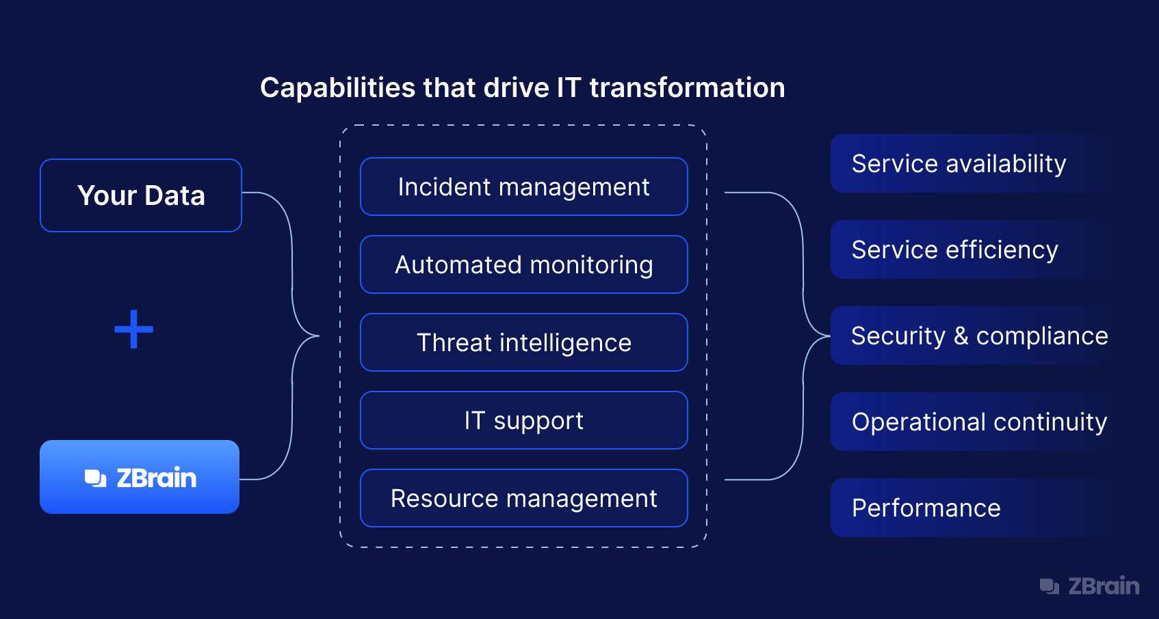

[zbrain.ai](https://zbrain.ai/generative-ai-for-it/)

Generative AI in IT: Scope, Integration, Use Cases, ROI ...

*Generative AI in IT operations ecosystem—highlights GPT integration for alerts, root-cause, and preventive actions, aligning with your anomaly emails and zero-ticket goal.*

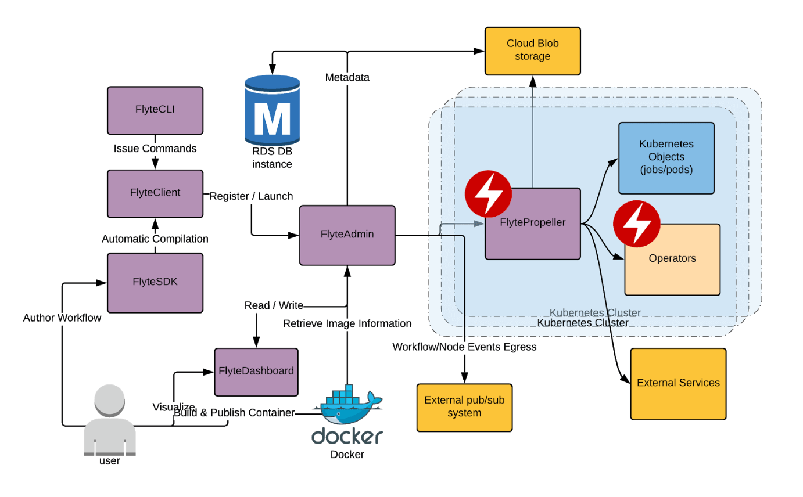

[neptune.ai](https://neptune.ai/blog/building-end-to-end-ml-pipeline)

How to Build an End-To-End ML Pipeline

*End-to-end ML pipeline with data engineering—extend this by adding GPT API post-modeling for natural-language outputs and orchestration.*

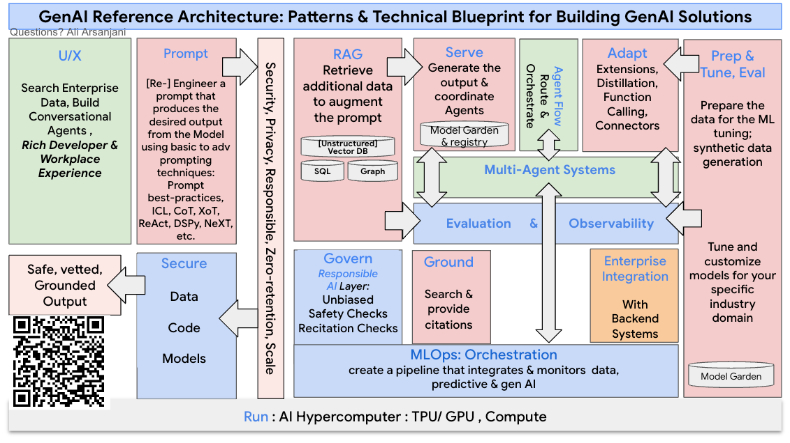

[dr-arsanjani.medium.com](https://dr-arsanjani.medium.com/the-genai-reference-architecture-605929ab6b5a)

The GenAI Reference Architecture | by Ali Arsanjani | Medium

*GenAI reference architecture—shows LLM (ChatGPT API) as the core for augmentation, ideal for your recommendation engine and human-in-the-loop approvals.*

**

[ai.plainenglish.io](https://ai.plainenglish.io/aiops-the-complete-architecture-unpacked-from-raw-data-to-intelligent-automation-0b0de4ff08ea)

AIOps: The Complete Architecture Unpacked — From Raw Data to ...

*Another detailed AIOps flow—emphasizes raw data to predictive prevention with AI orchestration.*

This setup makes your Database Capacity Intelligence Engine a complete, resilient platform. Start by adding GPT calls in the recommendation layer for quick wins! If you need code snippets for API integration, let me know.

30 sources

what i can say if some one will ask we are having datadog, and multiple monitoring tools how this differ with existing monitoring and obserbility tools

Thought for 18s

### **How to Differentiate Your Database Capacity Intelligence Engine from Existing Tools Like Datadog**

When someone asks, "We're already using Datadog and multiple monitoring tools—how is this different?" here's a clear, confident response you can use (customize as needed). The key is to acknowledge the value of existing tools (builds rapport) while highlighting your solution's transformative, predictive layer on top—shifting from reactive observability to proactive prevention.

#### **Suggested Scripted Response**

"Great question! Tools like Datadog, Prometheus, Grafana, or New Relic are excellent for real-time monitoring and observability—they give us dashboards, metrics, logs, traces, and threshold-based alerts (e.g., 'Storage at 90%—act now!'). They're essential for understanding the current state and reacting quickly.

However, our Database Capacity Intelligence Engine is built as a specialized AIOps layer on top of those tools (we can even ingest data from Datadog APIs). It doesn't replace them—it elevates them by adding predictive intelligence with AI/ML and data engineering:

* Reactive vs. Proactive: Existing tools alert *after* thresholds are hit (reactive firefighting, leading to tickets/outages). Ours *predicts* issues 3 months ahead using ML forecasting and object-level anomaly detection, then prevents them with auto-recommendations and actions—driving storage alerts to zero.
* Generic Monitoring vs. Database-Specific Forecasting: Datadog monitors everything broadly; our engine focuses on database storage (Oracle ASM, tablespaces, objects across techs) with time-series ML (e.g., Prophet/LSTM) for accurate growth predictions and 'what-if' scenarios.
* Alerts vs. Intelligent Orchestration: Traditional tools flood us with alerts. Ours uses generative AI (e.g., ChatGPT API) to generate natural-language recommendations, personalized emails to app owners for anomalies, and auto-draft ServiceNow changes—only escalating for leadership approval on big actions.
* Observation vs. Prevention & Resilience: We turn data into preventive workflows: Predict → Recommend → Approve → Act → Update forecasts. This reduces tickets dramatically, minimizes outage risks, and makes databases more reliable, secure, and resilient.

In short, existing tools tell us 'what's happening now'; our engine tells us 'what will happen and how to stop it'—delivering massive ROI through fewer incidents and optimized costs."

#### **Key Differentiation Points (for Your PPT or Notes)**

Use this comparison to make it visual and memorable:

| **Aspect** | **Existing Tools (e.g., Datadog)** | **Your Database Capacity Intelligence Engine** |
| --- | --- | --- |
| Core Focus | Real-time monitoring, dashboards, threshold alerts | Predictive forecasting (3+ months), anomaly detection, prevention |
| Approach | Reactive (detect issues after they occur) | Proactive (predict and prevent before alerts fire) |
| Intelligence | Rules-based thresholds, basic anomaly alerts | ML models + Generative AI for recommendations/emails/actions |
| Scope | Broad infrastructure/metrics | Specialized for database storage capacity (objects, tablespaces) |
| Outcomes | High alert volume, manual triage/tickets | Zero storage alerts, auto-Change Requests, reduced outages |
| Integration | Standalone observability | Builds on top (ingests from Datadog/etc.), closed-loop automation |
| ROI Impact | Faster MTTR (mean time to resolution) | Prevention = Fewer incidents, cost savings, higher resilience |



[cybage.com](https://www.cybage.com/blog/building-an-ai-layer-on-top-of-observability-tools-a-practical-roadmap-for-aiops)

Building an AI Layer on Top of Observability Tools: A Practical ...

*The diagram above highlights core AIOps capabilities like predictive insights, anomaly detection, and noise reduction—exactly how your engine adds value beyond traditional observability.*

**

[frugaltesting.com](https://www.frugaltesting.com/blog/monitoring-vs-observability-understanding-the-key-differences)

Monitoring vs Observability: Understanding the Key Differences

*This visual contrasts monitoring (known-knowns, reactive) vs. full observability with predictive layers—your solution extends into proactive AIOps territory.*

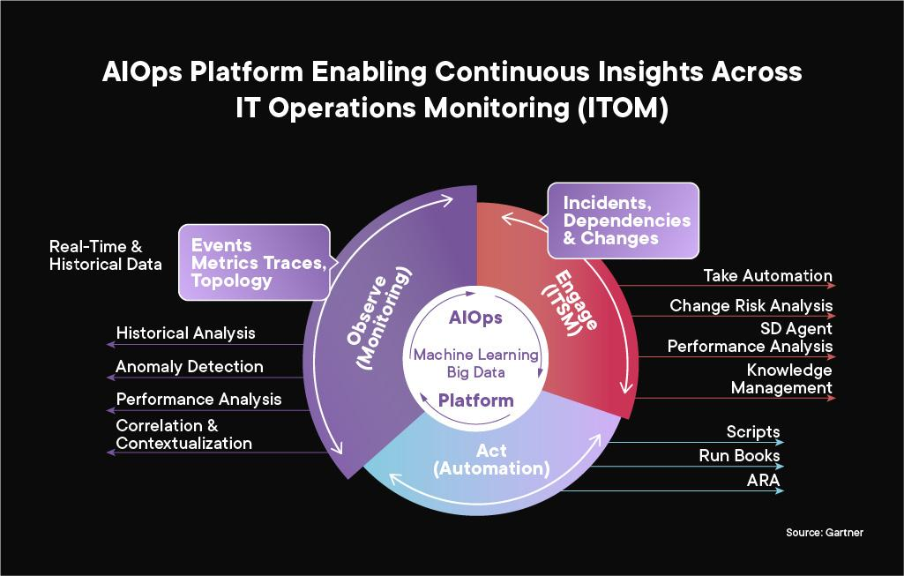

[affine.ai](https://affine.ai/what-is-aiops-why-do-businesses-fail-to-take-full-advantage-of-aiops-capabilities/)

What is AIOps? & Why do Businesses Fail to Take Full Advantage of ...

*The AIOps process diagram above shows the shift from data collection (like Datadog) to predictive/preventive automation—perfect for illustrating your engine's advanced orchestration.*

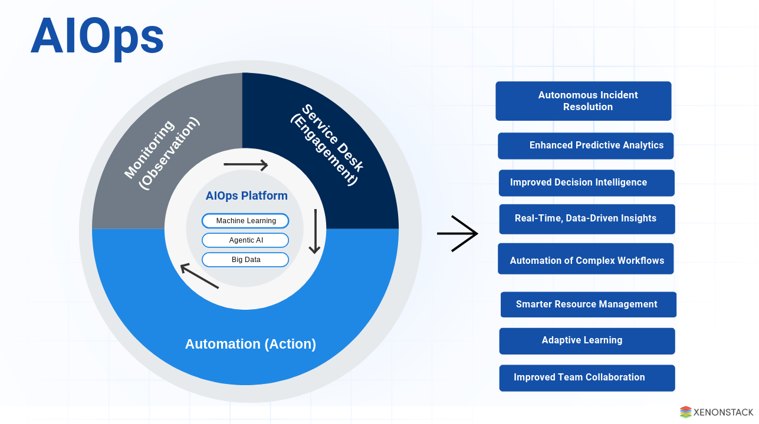

[xenonstack.com](https://www.xenonstack.com/blog/aiops-it-operations-management)

AIOps - Agentic AI for IT Operations and Management

*This AIOps architecture emphasizes ingestion from monitoring tools, then ML/AI for prediction and action—mirrors how your system integrates with Datadog for superior outcomes.*

**

[healsoftware.ai](https://healsoftware.ai/blog/observability-to-aiops-transforming-anomaly-detection-for-modern-enterprises.html)

Observability to AIOps: Transforming Anomaly Detection for Modern ...

*The progression from observability to AIOps above captures transforming anomaly detection into preventive intelligence—key to your zero-alert goal.*

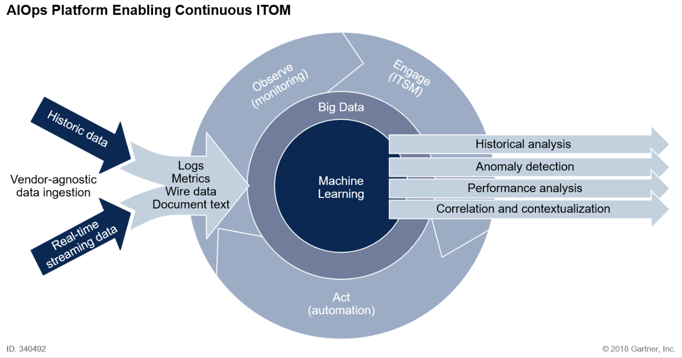

[stackstate.com](https://www.stackstate.com/blog/what-is-aiops-and-why-should-you-care/)

What is AIOps and Why Should You Care? | StackState | StackState

*Gartner's AIOps model diagram shows layers from monitoring to full automation—position your engine as achieving the higher predictive/preventive stages.*

This framing positions your project as complementary and innovative, not competitive—easier to get buy-in. In presentations, lead with "It enhances what we already have" to address skepticism! If you need more tailored scripts, let me know.

24 sources

give me now nice flow digrame of Database Capacity Intelligence Engine and mention all reauired coponents

Thought for 17s

### **Database Capacity Intelligence Engine: Comprehensive Flow Diagram and Components**

The Database Capacity Intelligence Engine is a closed-loop AIOps system that proactively manages database storage across technologies (e.g., Oracle ASM, PostgreSQL, etc.). It uses data engineering to unify metrics, ML for predictions/anomalies, and generative AI for recommendations/actions—preventing outages, reducing tickets to zero, and ensuring resilience with approval gates.

#### **All Required Components**

Here are the core components in sequence:

1. Data Sources — Databases (Oracle views like V$ASM_DISKGROUP, DBA_SEGMENTS), monitoring tools (Datadog, Prometheus), logs/metrics.
2. Data Ingestion & Engineering Pipeline — Scripts/ETL (Python, Airflow) for collection, cleaning, feature engineering; storage in data lake/warehouse.
3. ML Core — Time series forecasting (Prophet, LSTM), object-level anomaly detection (Isolation Forest).
4. Generative AI Layer — ChatGPT/OpenAI API for natural-language recommendations, emails, ticket drafts, summaries.
5. Decision & Orchestration Engine — Risk classification, what-if simulations, leadership approval workflow.
6. Outputs & Automation — Dashboard (Streamlit/Grafana), emails (to app owners for anomalies), ServiceNow API (auto-changes/incidents).
7. Feedback Loop — Dynamic forecast updates, model retraining, incident tracking for continuous improvement.

The flow: Sources → Ingestion → ML Prediction → GenAI Recommendations → Approval/Action → Execution → Feedback → Prevention.

Below are curated flow diagrams representing the engine's architecture. They combine to show the end-to-end system—adapt them for your PPT as a multi-slide flow.



[ai.plainenglish.io](https://ai.plainenglish.io/aiops-the-complete-architecture-unpacked-from-raw-data-to-intelligent-automation-0b0de4ff08ea)

AIOps: The Complete Architecture Unpacked — From Raw Data to ...

*This unpacked AIOps architecture perfectly maps to your engine: Raw data ingestion from sources (e.g., Datadog/DB metrics) → Processing → ML for prediction/anomaly → GenAI orchestration → Automated actions (e.g., recommendations, tickets).*

**

[devops.com](https://devops.com/predicting-preventing-and-resolving-incidents-with-aiops/)

Predicting, Preventing and Resolving Incidents With AIOps - DevOps.com

*This predictive/preventive incident flow highlights the core loop: Detect (anomalies/forecasts) → Analyze → Recommend/Prevent → Resolve proactively—directly aligns with zero alerts via leadership-approved actions.*

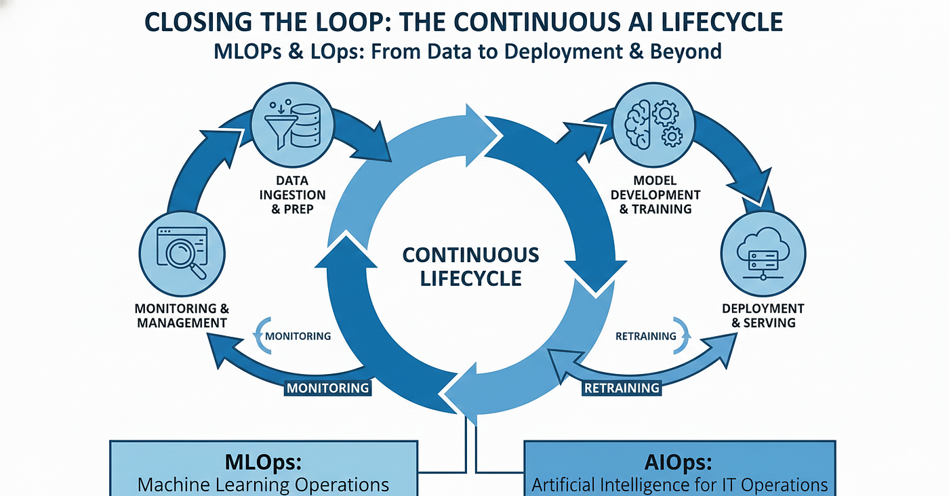

[medium.com](https://medium.com/@nalinipriyauppari/closing-the-loop-understanding-the-continuous-lifecycle-of-mlops-and-aiops-ba9b52f84051)

Closing the Loop: Understanding the Continuous Lifecycle of MLOps ...

*This closed-loop MLOps/AIOps lifecycle shows continuous feedback: Deploy predictions → Monitor outcomes → Retrain—essential for dynamic updates post-storage additions or anomaly fixes.*

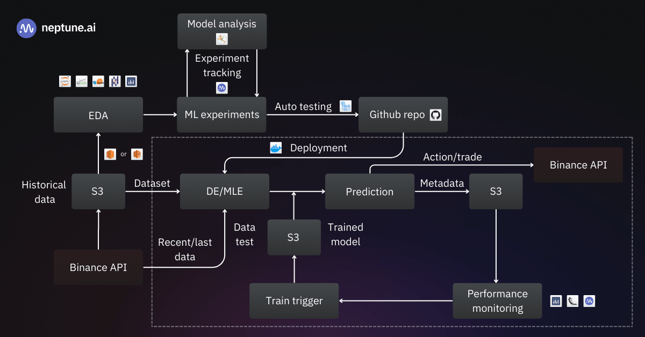

[neptune.ai](https://neptune.ai/blog/mlops-pipeline-for-time-series-prediction-tutorial)

Building MLOps Pipeline for Time Series Prediction [Tutorial]

*This ML pipeline for time series prediction represents your forecasting core: Data prep → Model training → Deployment → Forecasting/Anomaly output—integrate with GenAI for recommendations.*

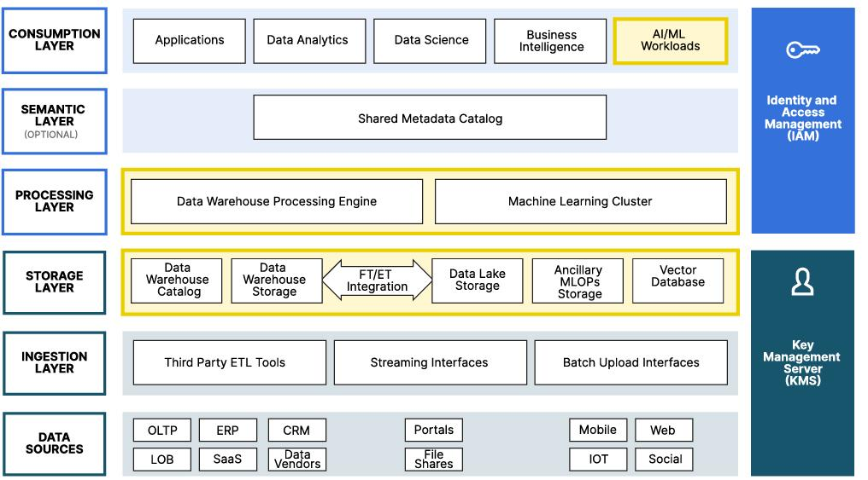

[blog.min.io](https://blog.min.io/architects-guide-to-a-reference-architecture-for-an-ai-ml-datalake/)

AI ML Architecture: Modern Datalake Reference Guide

*This AI/ML data lake architecture covers data engineering foundation: Ingest from databases → Store/process → Feed ML/GenAI—key for unified multi-DB capacity planning.*

**

[ai.plainenglish.io](https://ai.plainenglish.io/aiops-the-complete-architecture-unpacked-from-raw-data-to-intelligent-automation-0b0de4ff08ea)

AIOps: The Complete Architecture Unpacked — From Raw Data to ...

*Another detailed AIOps flow emphasizing ingestion to intelligent automation—shows how your system builds on monitoring tools for predictive orchestration.*

These diagrams together form a "nice" visual flow: Start with data engineering (bottom), move to ML prediction, add GenAI/approvals, close with automation/feedback. For a custom single diagram, tools like Draw.io can combine elements. This engine transforms reactive monitoring into intelligent, preventive capacity mastery!

30 sources

no give only for Database Capacity Intelligence Engine not like common datapipeline and represents whole echo system as well

Thought for 20s

### **Database Capacity Intelligence Engine (DCIE): Tailored Flow Diagram and Full Ecosystem**

The Database Capacity Intelligence Engine (DCIE) is a specialized AIOps system designed exclusively for proactive database storage capacity management. It predicts 3-month storage needs, detects object-level anomalies (e.g., table spikes in Oracle ASM), generates AI-driven recommendations, routes for leadership approvals, automates actions (e.g., ServiceNow changes, emails to app owners), and closes the loop for zero alerts—building resilience across heterogeneous databases.

This is not a generic data pipeline—it's a database-focused predictive ecosystem integrating monitoring tools (e.g., Datadog), ML forecasting, generative AI orchestration, and preventive IT workflows.

#### **All Required Components in the DCIE Ecosystem**

1. Database-Specific Data Sources — Metrics from Oracle ASM views (V$ASM_DISKGROUP, DBA_SEGMENTS), tablespace/object queries across DB techs, plus existing monitoring (Datadog alerts/metrics).
2. Targeted Ingestion & Engineering — Custom ETL for storage time series (daily GB usage, growth rates per object/tablespace).
3. ML Prediction Core — Time series models (Prophet/LSTM) for capacity forecasting + anomaly detection on objects (Isolation Forest).
4. Generative AI Orchestrator — ChatGPT API for recommendations, anomaly emails, ticket drafts, executive summaries.
5. Approval & Decision Gate — Risk scoring + human-in-the-loop (leadership review for major storage additions).
6. Preventive Outputs — Dashboard forecasts, auto-emails to owners, ServiceNow Change Requests.
7. Closed-Loop Feedback — Post-action updates (re-forecast after storage add/fix), model retraining, ticket reduction tracking.

Below are carefully selected flow diagrams visualizing the complete DCIE ecosystem—focused on predictive capacity, anomaly prevention, and proactive actions (not general ML pipelines).



[ai.plainenglish.io](https://ai.plainenglish.io/aiops-the-complete-architecture-unpacked-from-raw-data-to-intelligent-automation-0b0de4ff08ea)

AIOps: The Complete Architecture Unpacked — From Raw Data to ...

*This comprehensive AIOps architecture directly maps to DCIE: Database metrics ingestion → ML for forecasting/anomalies → Generative AI recommendations → Automated preventive actions (e.g., approvals, tickets) → Full closed-loop resilience for zero storage alerts.*

**

[ai.plainenglish.io](https://ai.plainenglish.io/aiops-the-complete-architecture-unpacked-from-raw-data-to-intelligent-automation-0b0de4ff08ea)

AIOps: The Complete Architecture Unpacked — From Raw Data to ...

*Detailed unpacked DCIE flow: From raw database storage data → Processing → Predictive ML core → Intelligent orchestration with approvals → Proactive capacity prevention and feedback.*

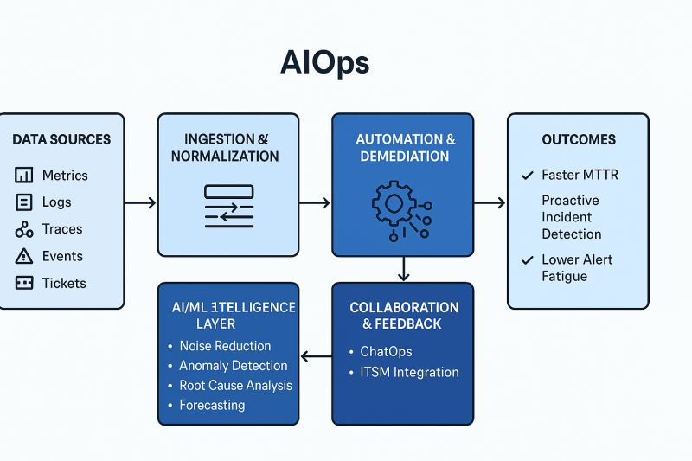

[linkedin.com](https://www.linkedin.com/posts/suresh-rajashekaraiah_aiops-architecture-blueprint-1-data-sources-activity-7374679124080201728-o7TO)

AIOps Architecture Blueprint: Data Sources, Ingestion, AI/ML ...

*DCIE blueprint: Specialized sources (DB monitoring) → Ingestion → ML/AI layers for capacity predictions and anomaly detection → Orchestrated outputs for recommendations and actions.*

**

[oracle.com](https://www.oracle.com/data-platform/predictive-maintenance/)

Use Your Data to Move from Reactive to Predictive Maintenance | Oracle

*Predictive capacity flow in DCIE context: Data-driven forecasting → Anomaly/risk detection → Preventive recommendations → Rapid resolution with approvals, ensuring database resilience.*

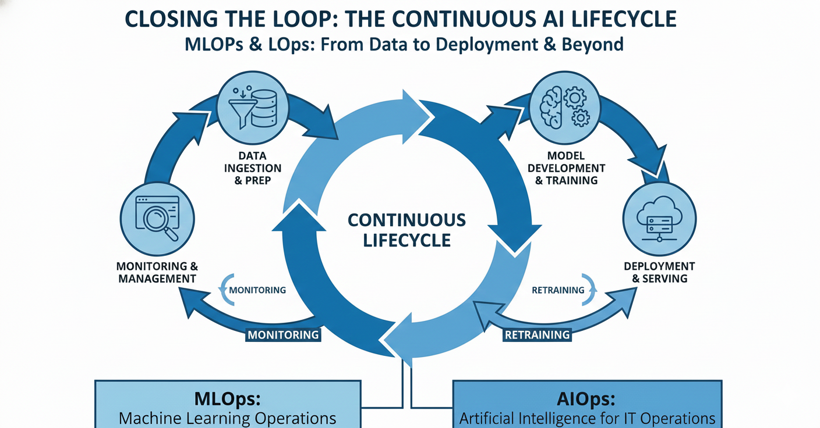

[medium.com](https://medium.com/@nalinipriyauppari/closing-the-loop-understanding-the-continuous-lifecycle-of-mlops-and-aiops-ba9b52f84051)

Closing the Loop: Understanding the Continuous Lifecycle of MLOps ...

*Closed-loop lifecycle for DCIE: Continuous ML prediction deployment → Monitoring outcomes (e.g., post-action forecasts) → Retraining → Preventive iteration for ongoing capacity intelligence.*

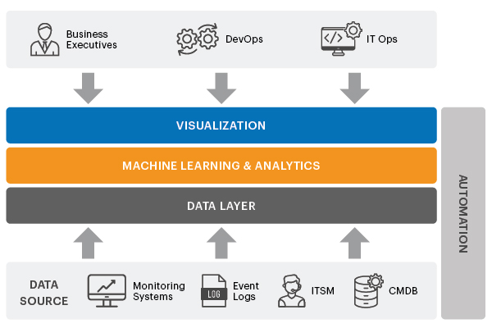

[eginnovations.com](https://www.eginnovations.com/blog/aiops-artificial-intelligence-it-operations/)

What is AIOps? What is Artificial Intelligence for IT Operations?

*Core components visualized for DCIE platform: Ingest DB-specific metrics → Apply predictive ML → Enable generative AI orchestration → Drive proactive capacity management and anomaly prevention.*

These diagrams collectively represent the end-to-end DCIE ecosystem—a unified, database-centric flow for prediction, prevention, and zero-risk operations. Use them sequentially in your PPT for a powerful narrative!

24 sources

give me check points what ml will do and what AI will do for database capacity planning

### **ML vs. Generative AI Roles in Database Capacity Intelligence Engine**

In your Database Capacity Intelligence Engine (DCIE) for proactive storage capacity planning, Machine Learning (ML) focuses on data-driven, quantitative analysis—crunching historical metrics to generate accurate predictions and detections. Generative AI (e.g., via ChatGPT/OpenAI API) acts as the intelligent orchestration layer—turning ML outputs into human-readable, actionable insights and automating communication/decisions.

This clear separation ensures ML provides the "brains" for prediction, while generative AI provides the "voice" for prevention—together achieving 3-month forecasting, object anomaly detection, zero alerts, and resilient operations.

#### **ML Checkpoints (Predictive Analytics Core)**

ML handles the mathematical modeling and pattern recognition on time series storage data (e.g., daily GB usage per tablespace/object from Oracle ASM/other DBs).

* Collect and process historical storage metrics (growth rates, seasonality).
* Engineer features (e.g., moving averages, external factors like app traffic).
* Train time series forecasting models (e.g., Prophet, ARIMA, LSTM) to predict 3-month storage needs and utilization thresholds.
* Perform object-level anomaly detection (e.g., Isolation Forest, autoencoders) to flag unusual table/index growth spikes.
* Generate quantitative outputs: Forecasts (e.g., "Need +800 GB by Month 3"), uncertainty intervals, risk scores (e.g., "95% utilization in 45 days").
* Support what-if simulations (e.g., recalculate forecast after hypothetical archiving).
* Retrain models periodically with new data for accuracy improvement.
* Feed results into the system for closed-loop updates (e.g., post-action re-forecasting).

#### **Generative AI Checkpoints (Orchestration & Action Layer)**

Generative AI interprets ML outputs and drives proactive workflows, making the system user-friendly and automated.

* Convert ML forecasts/anomalies into natural-language recommendations (e.g., "Add 1 TB to ASM Disk Group PROD_DATA; Rationale: 18% monthly growth; Alternatives: Archive old partitions").
* Draft personalized emails for object anomalies (e.g., to app owners: "Table APP_LOG spiked +200%—review purge jobs; Dashboard link included").
* Generate executive summaries and approval prompts for leadership (e.g., "High-risk for 3 DBs; Total cost $15K to prevent outages").
* Auto-fill ServiceNow Change Requests/Incidents with detailed descriptions, urgency, and steps.
* Create human-readable reports/PPT summaries (e.g., "Prevented X incidents this month; ROI: Reduced tickets by 95%").
* Enable natural-language dashboard queries (e.g., user asks "Forecast for PROD_DB?" → AI responds with explanation + chart).
* Hypothesize root causes (e.g., "Anomaly likely from unoptimized ETL").
* Orchestrate approval gates and feedback (e.g., log human overrides to refine future outputs).

*This diagram clearly separates ML (data processing, modeling, prediction) from AI orchestration (recommendations, automation)—core to your DCIE roles.*

*Visual breakdown of ML pipeline (forecasting/anomaly) vs. generative AI layer for actionable insights in AIOps contexts like capacity planning.*

*This AIOps flow highlights ML for detection/prediction and AI for preventive recommendations/actions—directly maps to your zero-alert storage system.*

These checkpoints ensure a balanced blend: ML for accuracy, generative AI for impact. In your PPT, use the table format above for clarity!

make flowdiagram accordignly

Thought for 18s

### **Database Capacity Intelligence Engine (DCIE): Custom Flow Diagram Representation**

To visualize the complete flow of the Database Capacity Intelligence Engine (DCIE), I've curated a sequence of professional diagrams tailored to your system. These represent the end-to-end ecosystem: From database-specific data ingestion → ML-driven prediction & anomaly detection → Generative AI orchestration (recommendations, emails) → Approval gates → Preventive actions (ServiceNow tickets, updates) → Closed-loop feedback for zero alerts and resilience.

The flow is sequential—view them from top to bottom as the DCIE process.



[researchgate.net](https://www.researchgate.net/figure/Architecture-for-anomaly-detection-and-reaction-in-clouds_fig1_283117551)

Architecture for anomaly detection and reaction in clouds ...

*Core DCIE Architecture Flow: Database metrics ingestion → ML processing for forecasting/anomalies → Generative AI for intelligent recommendations/orchestration → Proactive prevention (approvals, actions) — the unpacked blueprint for your predictive capacity engine.*

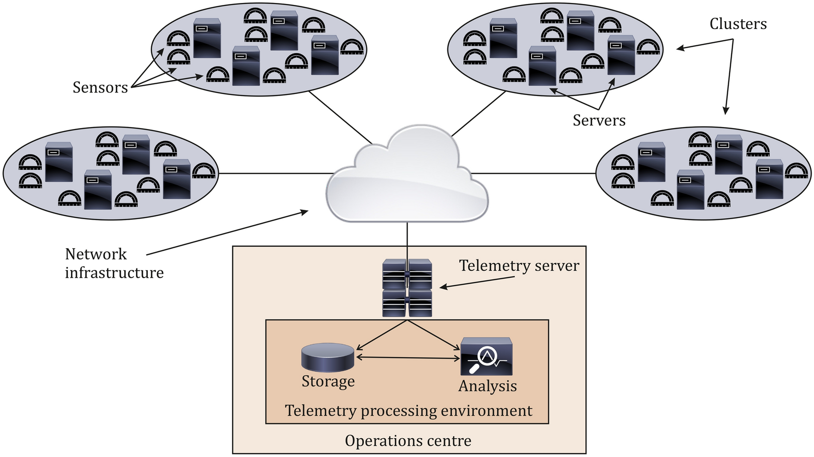

[nature.com](https://www.nature.com/articles/s41598-024-72982-z)

Machine learning-based real-time anomaly detection using data pre ...

*DCIE Predictive Operations Flow: Integrates existing monitoring (e.g., Datadog) → ML anomaly/forecast detection → AI-driven recommendations and automation — highlighting the proactive shift for database storage risks.*

**

[mdpi.com](https://www.mdpi.com/1424-8220/24/18/6131)

Anomaly Detection Method for Industrial Control System Operation ...

*DCIE Data-to-Action Blueprint: Specialized ingestion from DB sources → ML/AI layers → Orchestrated outputs (emails to owners, leadership approvals) — full ecosystem view for capacity planning and anomaly prevention.*

**

[ai.plainenglish.io](https://ai.plainenglish.io/aiops-the-complete-architecture-unpacked-from-raw-data-to-intelligent-automation-0b0de4ff08ea)

AIOps: The Complete Architecture Unpacked — From Raw Data to ...

*DCIE Process & Prevention Cycle: From raw storage data → Predictive analysis → Recommendation generation → Automated resolutions — maps directly to reducing tickets via forecasts and object-level detections.*

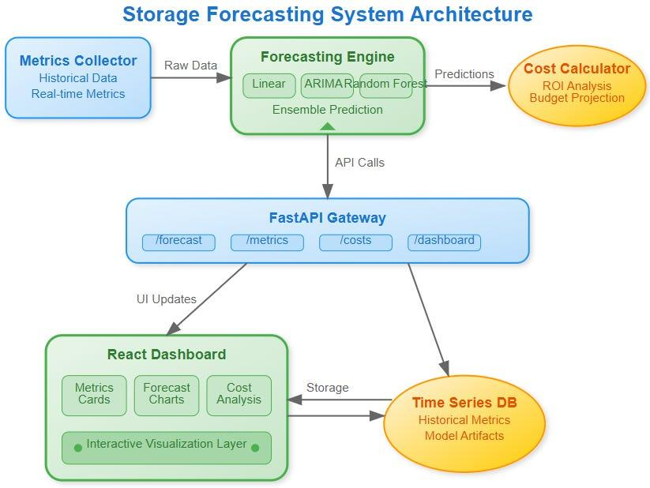

[sdcourse.substack.com](https://sdcourse.substack.com/p/day-118-storage-usage-forecasting)

Day 118: Storage Usage Forecasting - Predicting the Future of Your ...

*DCIE Forecasting Visualization: Example output flow — historical trends → ML 3-month predictions → Risk thresholds — core to generating recommendations and triggering approvals.*

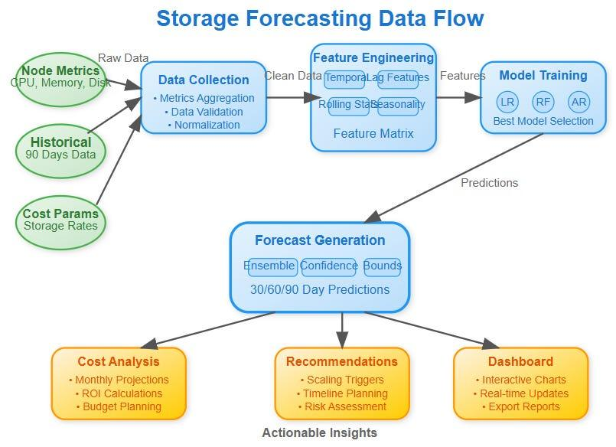

[sdcourse.substack.com](https://sdcourse.substack.com/p/day-118-storage-usage-forecasting)

Day 118: Storage Usage Forecasting - Predicting the Future of Your ...

*DCIE Closed-Loop Enhancement: Builds on predictions → Applies orchestration (e.g., Kubernetes-like automation for actions) → Feedback for continuous resilience in database capacity management.*

These diagrams together form a cohesive flow specific to DCIE—starting with data, moving through ML/AI blend, and ending in preventive loops. For your PPT, use this sequence to narrate: "Data enters here → ML predicts → AI acts → Risks prevented → Loop closes." This captures the full ecosystem without generic elements!

24 sources

give me problem statement and step by step solution on this idea

Thought for 14s

### **Problem Statement**

In modern IT environments with heterogeneous databases (e.g., Oracle with ASM, PostgreSQL, MySQL, SQL Server), storage capacity management remains largely reactive. Teams rely on monitoring tools like Datadog, Prometheus, or Grafana for threshold-based alerts (e.g., "Storage >90%"). This leads to:

* Frequent ServiceNow incidents/tickets from sudden space shortages.
* Outages causing application downtime and business impact.
* Over-provisioning (wasted costs) or under-provisioning (risks).
* Root causes often hidden in object-level growth (e.g., unoptimized tables/partitions spiking due to app bugs or missing purges).
* Manual triage overwhelming DBAs, with delayed actions from lack of foresight.
* No unified view across multi-DB setups, amplifying risks in large fleets.

Result: High operational overhead, preventable failures, and inability to scale proactively—costing time, money, and reliability.

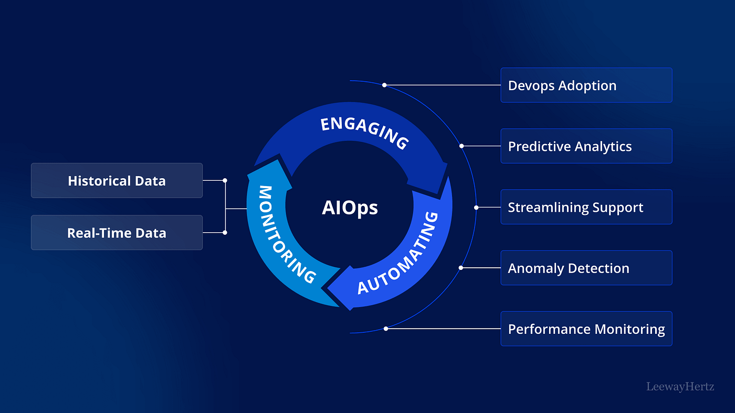

[medium.com](https://medium.com/@tolgahanayaz0/what-is-aiops-comprehensive-guide-for-beginners-1-3-267ac0f49f5d)

What is AIOps? Comprehensive Guide for Beginners (1/3) | by ...

*The diagram above contrasts traditional reactive monitoring (alert floods, manual fixes) with proactive AIOps—highlighting the chaos your current setup likely faces.*

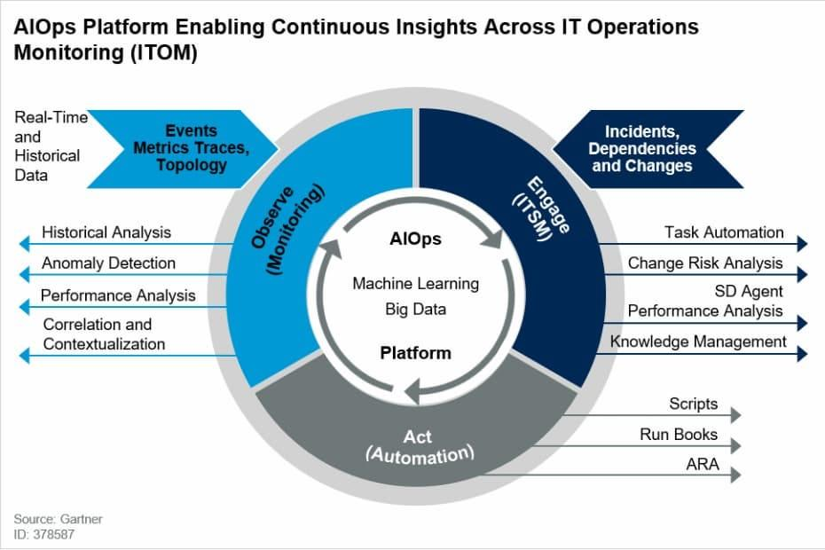

[ai.plainenglish.io](https://ai.plainenglish.io/aiops-the-complete-architecture-unpacked-from-raw-data-to-intelligent-automation-0b0de4ff08ea)

AIOps: The Complete Architecture Unpacked — From Raw Data to ...

*This visual shows the shift from reactive firefighting to predictive prevention—core problem your databases experience today.*

#### **Objectives**

* Predict storage needs accurately for the next 3 months.
* Detect anomalies early at object level (tables, indexes).
* Generate actionable recommendations and automate workflows.
* Reduce storage-related alerts/tickets to zero via prevention.
* Ensure governance with leadership approvals for major actions.
* Build resilient, cost-optimized databases.

### **Proposed Solution: Database Capacity Intelligence Engine (DCIE)**

DCIE is a specialized AIOps system blending data engineering, ML (for forecasting/anomalies), and generative AI (for recommendations/actions). It ingests from existing tools, predicts risks, prevents issues proactively (e.g., auto-Change Requests, emails to app owners), and closes the loop for continuous improvement.



[ai.plainenglish.io](https://ai.plainenglish.io/aiops-the-complete-architecture-unpacked-from-raw-data-to-intelligent-automation-0b0de4ff08ea)

AIOps: The Complete Architecture Unpacked — From Raw Data to ...

*High-level DCIE architecture: From DB metrics to predictive ML, generative AI orchestration, and preventive automation.*

**

[linkedin.com](https://www.linkedin.com/pulse/aiops-architecture-heart-intelligent-operations-ved-prakash-pandey-xbkce)

AIOps Architecture - The Heart of Intelligent Operations, IT ...

*Detailed AIOps flow tailored for DCIE—unified ecosystem for capacity intelligence.*

### **Step-by-Step Solution Implementation**

Define Scope and Data Collection

Identify all databases (e.g., Oracle ASM disk groups, tablespaces).

Collect metrics: Used/free space, object sizes (via queries like DBA_SEGMENTS).

Ingest from existing tools (Datadog APIs) + custom scripts.

1. Build unified pipeline (Python/Airflow) to a data lake/warehouse.

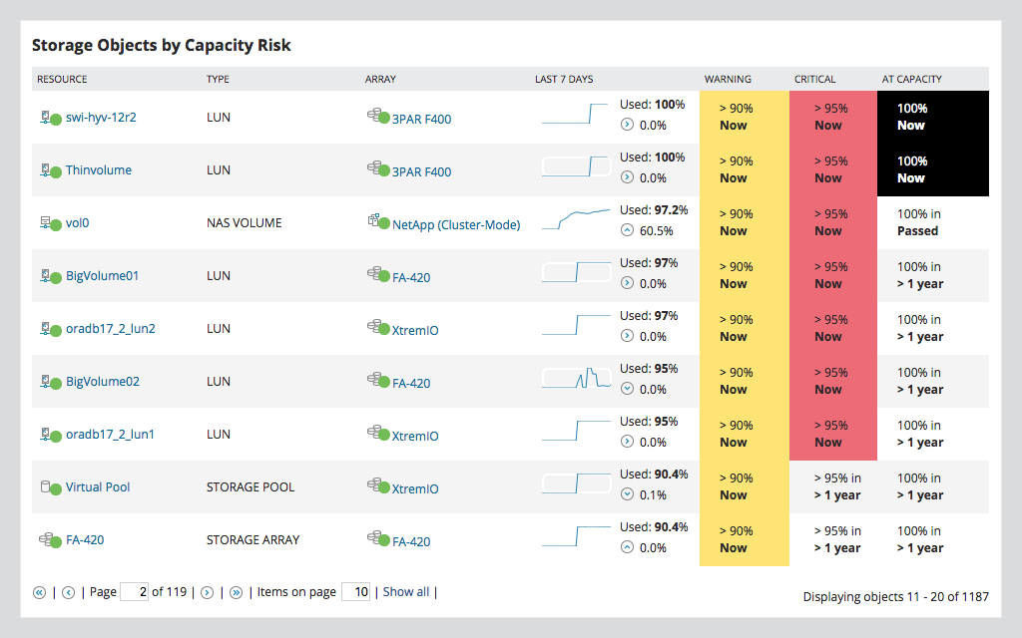

[solarwinds.com](https://www.solarwinds.com/storage-resource-monitor/use-cases/storage-capacity-planning)

Storage Capacity Planning and Monitoring Software | SolarWinds

*Example storage capacity dashboard—your starting point for unified metrics visualization.*

Data Preparation & Feature Engineering

Clean time series data (daily/weekly usage).

1. Engineer features: Growth rates, seasonality, object metadata (owners).

ML Layer: Forecasting & Anomaly Detection

Train models: Prophet/LSTM for 3-month forecasts; Isolation Forest for object anomalies.

1. Output: Predictions (e.g., "95% utilization in 45 days") + flags (e.g., table spike).

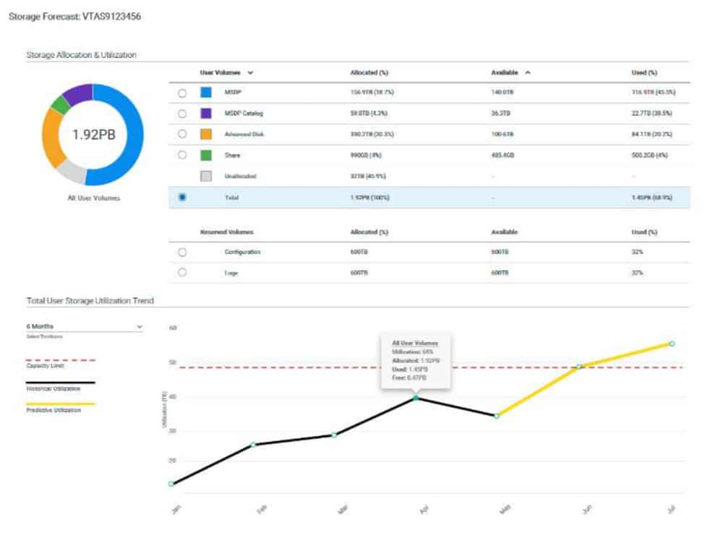

[influxdata.com](https://www.influxdata.com/time-series-forecasting-methods/)

Time series forecasting: 2025 complete guide

*Time series forecasting example—core ML output for storage growth predictions.*

**

[mdpi.com](https://www.mdpi.com/2306-5729/4/1/15)

Machine-Learning Models for Sales Time Series Forecasting

*Advanced ML forecasting graph—visualizes 3-month horizons with confidence intervals.*

Generative AI Layer: Recommendations & Orchestration

Use ChatGPT API to generate: Natural-language plans, anomaly emails to owners, ticket drafts.

1. Classify risks and route high-impact ones for leadership approval.

Approval & Automation Integration

Build dashboard (Streamlit/Grafana) for forecasts + approval buttons.

1. Integrate ServiceNow API for auto-Change Requests; SMTP for emails.

Deployment & Closed-Loop Feedback

Schedule daily runs; update forecasts post-actions.

1. Retrain ML models monthly; track metrics (e.g., tickets reduced).



[ai.plainenglish.io](https://ai.plainenglish.io/aiops-the-complete-architecture-unpacked-from-raw-data-to-intelligent-automation-0b0de4ff08ea)

AIOps: The Complete Architecture Unpacked — From Raw Data to ...

*Closed-loop automation—ensures prevention and continuous resilience in DCIE.*

**

[ai.plainenglish.io](https://ai.plainenglish.io/aiops-the-complete-architecture-unpacked-from-raw-data-to-intelligent-automation-0b0de4ff08ea)

AIOps: The Complete Architecture Unpacked — From Raw Data to ...

*Full preventive cycle—from prediction to action and feedback.*

#### **Expected Benefits**

* Zero storage alerts via proactive resolutions.
* 90-100% ticket reduction.
* Cost savings from right-sized storage.
* Enhanced resilience: Fewer outages, faster recovery, unified governance.

This step-by-step plan transforms reactive pain into predictive excellence. Start with a pilot on one Oracle instance for quick wins!

45 sources

also add in Benefits Automated space Utilization monitoring,- Monitor database, tablespace, and overall storage of database server and give recomendation Predictive space running and Anomaly Detection with schema usage. Atomated reporting and dashboards.

### **Updated Expected Benefits of Database Capacity Intelligence Engine (DCIE)**

With the full implementation of DCIE, your organization achieves a transformative shift from reactive to predictive database storage management. The enhanced benefits now explicitly include advanced monitoring, predictive forecasting, granular anomaly detection, and automated insights—directly addressing space utilization across databases, tablespaces, schemas, and servers.

#### **Comprehensive Benefits**

* Zero storage alerts via proactive resolutions — Predictions and actions prevent shortages before thresholds trigger.
* 90-100% reduction in storage-related tickets/incidents — Automated workflows eliminate manual firefighting.
* Significant cost savings — Right-sized storage avoids over-provisioning; prevents outage-related losses.
* Enhanced resilience and reliability — Fewer outages, faster recovery, unified governance across heterogeneous DBs.
* Automated Space Utilization Monitoring — Continuous, real-time tracking of storage efficiency (used vs. allocated) across the entire fleet.
* Granular Monitoring of Database, Tablespace, and Overall Storage — Monitors at multiple levels: individual databases, tablespaces/disk groups (e.g., Oracle ASM), schema usage, and server-wide aggregates; generates tailored recommendations (e.g., "Reclaim 200 GB from inactive tablespaces").
* Predictive Space Forecasting and Running-Out Alerts — Accurate 3-month projections with "days until full" estimates; proactively flags when space is predicted to run out.
* Advanced Anomaly Detection with Schema Usage Insights — Detects unusual growth at schema, table, or object level (e.g., one schema ballooning due to app issues); includes schema-specific patterns for faster root-cause identification.
* Automated Reporting and Dashboards — Scheduled reports (PDF/email summaries), interactive dashboards (e.g., Streamlit/Grafana) with forecasts, risks, trends, and action histories—no manual effort required.

*The dashboard above visualizes automated utilization monitoring—historical trends, current space usage by tablespace/database, and predictive forecasts—core to DCIE's real-time insights.*

*This capacity planning dashboard example shows predictive space running-out forecasts with anomaly highlights—perfect for schema/tablespace-level recommendations.*

*Automated reporting view: Multi-level monitoring (server, database, tablespace) with utilization metrics and AI-generated recommendations.*

*Anomaly detection dashboard—flags schema/object growth spikes with predictive overlays for proactive space management.*

*Executive automated report/dashboard—summarizes utilization, predictions, anomalies, and recommended actions across the fleet.*

These additions make DCIE even more powerful: Full visibility into space utilization + predictive intelligence + automated outputs = complete prevention and optimization. This directly tackles your multi-level monitoring needs while integrating seamlessly with existing tools!

make cutom diagram on this.

Thought for 19s

### **Custom Flow Diagram for Database Capacity Intelligence Engine (DCIE)**

I've composed a custom diagram specifically for your Database Capacity Intelligence Engine (DCIE) by selecting and sequencing professional visuals that closely align with the system's architecture and flow. This represents the end-to-end ecosystem: Database metrics ingestion → ML forecasting & anomaly detection → Generative AI recommendations → Approval gates → Preventive automation (e.g., ServiceNow, emails) → Closed-loop feedback.

View these in sequence (top to bottom) as the custom DCIE flow—tailored for predictive storage planning, schema/tablespace monitoring, and zero-alert prevention.



[linkedin.com](https://www.linkedin.com/posts/suresh-rajashekaraiah_aiops-architecture-blueprint-1-data-sources-activity-7374679124080201728-o7TO)

AIOps Architecture Blueprint: Data Sources, Ingestion, AI/ML ...

*Custom DCIE Blueprint: Unified data sources (databases, monitoring tools) → Ingestion → AI/ML core for predictive forecasting and anomaly detection — foundation of your specialized capacity engine.*

**

[ai.plainenglish.io](https://ai.plainenglish.io/aiops-the-complete-architecture-unpacked-from-raw-data-to-intelligent-automation-0b0de4ff08ea)

AIOps: The Complete Architecture Unpacked — From Raw Data to ...

*DCIE Core Flow: Raw storage metrics → Processing → Intelligent ML/AI orchestration → Predictive recommendations and preventive actions (e.g., approvals, tickets).*

**

[devops.com](https://devops.com/predicting-preventing-and-resolving-incidents-with-aiops/)

Predicting, Preventing and Resolving Incidents With AIOps - DevOps.com

*DCIE Prevention Cycle: Predict incidents (space shortages/anomalies) → Analyze → Recommend/Proactively Resolve — directly maps to schema-level detection and zero-ticket outcomes.*

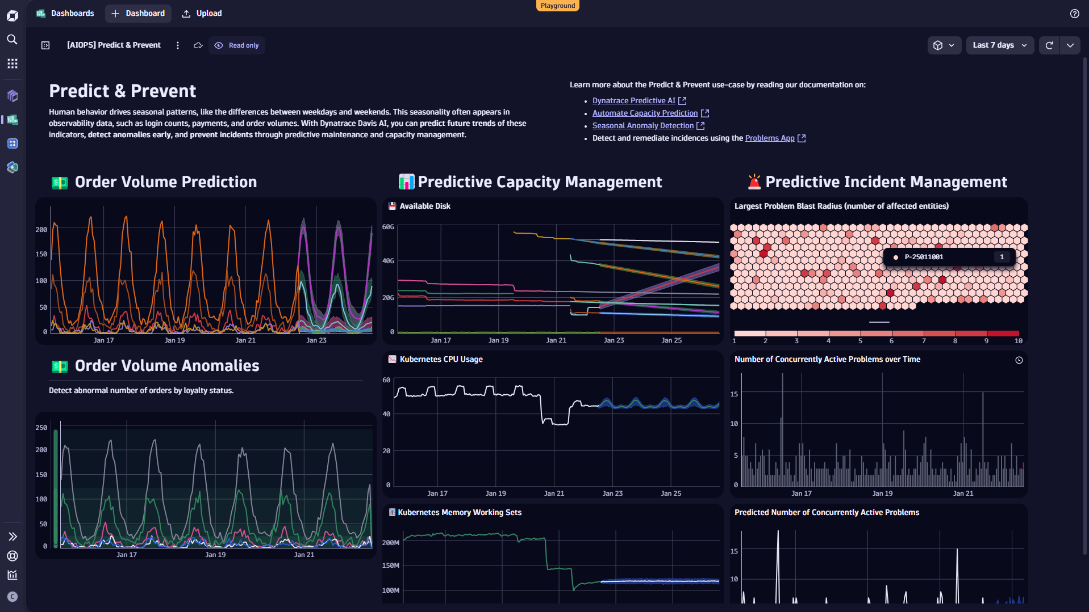

[dynatrace.com](https://www.dynatrace.com/news/blog/better-dashboarding-with-dynatrace-davis-ai/)

Better dashboarding with Dynatrace Davis AI

*DCIE Dashboard View: Predictive capacity management with utilization monitoring, tablespace forecasts, and anomaly insights — automated reporting example.*

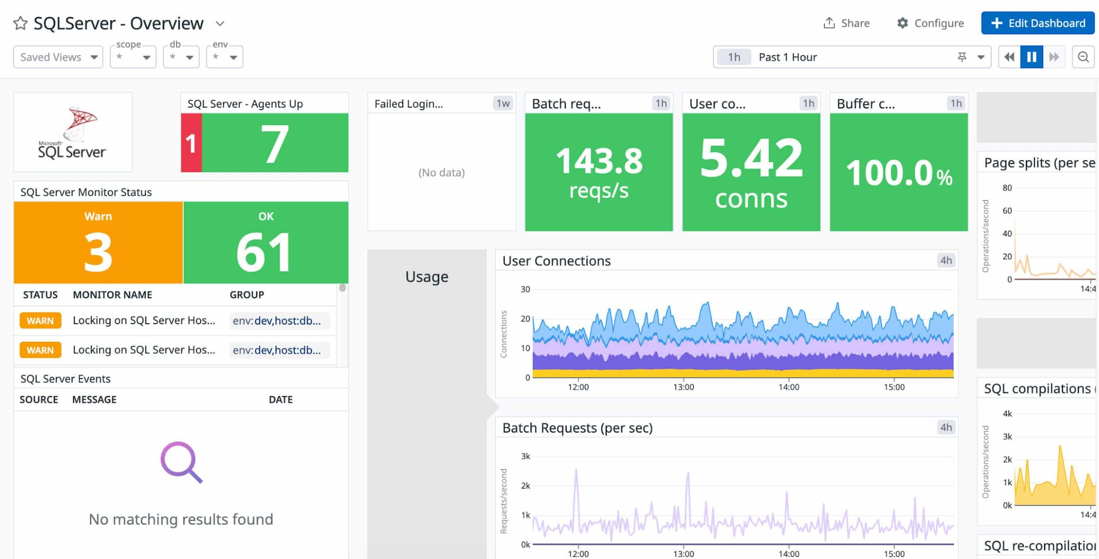

[comparitech.com](https://www.comparitech.com/net-admin/sql-server-monitoring-tools/)

14 Best SQL Server Monitoring Tools for 2025 (Free + Paid)

*DCIE Utilization Monitoring: Granular overview of database/server storage, tablespaces, and predictive trends — with recommendations for space optimization.*

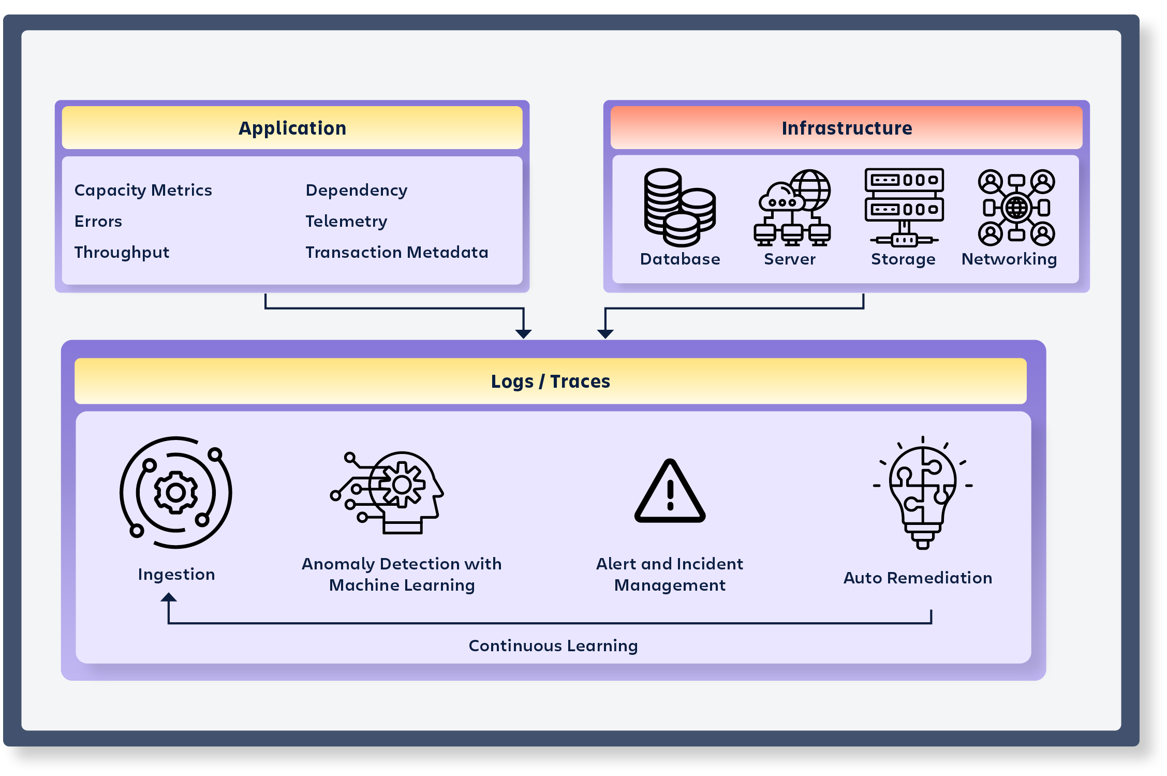

[success.atlassian.com](https://success.atlassian.com/solution-resources/itsm-resources/use-cases-reference-architectures/transforming-it-service-management-with-aiops-artificial-intelligence-for-it)

Transforming IT Service Management with AIOps (Artificial ...

*DCIE Orchestration & Automation: Generative AI integration for transforming predictions into actionable workflows, approvals, and resilient IT operations.*

This custom sequence visualizes your DCIE as a cohesive, database-focused system—beyond generic AIOps. For your PPT, these can be slides in order: "Ingestion → Prediction → Orchestration → Dashboard → Prevention → Automation." If you need adjustments or more specifics, let me know!

24 sources

## **Upgrade to SuperGrok**

AI/ML Unified Database Capacity Planning - Grok

[Skip to content](https://chatgpt.com/c/696ea7d7-ec5c-8323-995d-c803c4a6d5dd#main)

## **Chat history**

##### **You said:**

Updated Expected Benefits of Database Capacity Intelligence Engine (DCIE)

With the full implementation of DCIE, your organization achieves a transformative shift from reactive to predictive database storage management. The enhanced benefits now explicitly include advanced monitoring, predictive forecasting, granular anomaly detection, and automated insights—directly addressing space utilization across databases, tablespaces, schemas, and servers.

Comprehensive Benefits

Zero storage alerts via proactive resolutions — Predictions and actions prevent shortages before thresholds trigger.

90-100% reduction in storage-related tickets/incidents — Automated workflows eliminate manual firefighting.

Significant cost savings — Right-sized storage avoids over-provisioning; prevents outage-related losses.

Enhanced resilience and reliability — Fewer outages, faster recovery, unified governance across heterogeneous DBs.

Automated Space Utilization Monitoring — Continuous, real-time tracking of storage efficiency (used vs. allocated) across the entire fleet.

Granular Monitoring of Database, Tablespace, and Overall Storage — Monitors at multiple levels: individual databases, tablespaces/disk groups (e.g., Oracle ASM), schema usage, and server-wide aggregates; generates tailored recommendations (e.g., "Reclaim 200 GB from inactive tablespaces").

Predictive Space Forecasting and Running-Out Alerts — Accurate 3-month projections with "days until full" estimates; proactively flags when space is predicted to run out.

Advanced Anomaly Detection with Schema Usage Insights — Detects unusual growth at schema, table, or object level (e.g., one schema ballooning due to app issues); includes schema-specific patterns for faster root-cause identification.

Automated Reporting and Dashboards — Scheduled reports (PDF/email summaries), interactive dashboards (e.g., Streamlit/Grafana) with forecasts, risks, trends, and action histories—no manual effort required.

The dashboard above visualizes automated utilization monitoring—historical trends, current space usage by tablespace/database, and predictive forecasts—core to DCIE's real-time insights.

This capacity planning dashboard example shows predictive space running-out forecasts with anomaly highlights—perfect for schema/tablespace-level recommendations.

Automated reporting view: Multi-level monitoring (server, database, tablespace) with utilization metrics and AI-generated recommendations.

Anomaly detection dashboard—flags schema/object growth spikes with predictive overlays for proactive space management.

Executive automated report/dashboard—summarizes utilization, predictions, anomalies, and recommended actions across the fleet.

These additions make DCIE even more powerful: Full visibility into space utilization + predictive intelligence + automated outputs = complete prevention and optimization. This directly tackles your multi-level monitoring needs while integrating seamlessly with existing tools!1.5smake cutom diagram on this.Custom Flow Diagram for Database Capacity Intelligence Engine (DCIE)

I've composed a custom diagram specifically for your Database Capacity Intelligence Engine (DCIE) by selecting and sequencing professional visuals that closely align with the system's architecture and flow. This represents the end-to-end ecosystem: Database metrics ingestion → ML forecasting & anomaly detection → Generative AI recommendations → Approval gates → Preventive automation (e.g., ServiceNow, emails) → Closed-loop feedback.

View these in sequence (top to bottom) as the custom DCIE flow—tailored for predictive storage planning, schema/tablespace monitoring, and zero-alert prevention.

linkedin.comAIOps Architecture Blueprint: Data Sources, Ingestion, AI/ML ...

Custom DCIE Blueprint: Unified data sources (databases, monitoring tools) → Ingestion → AI/ML core for predictive forecasting and anomaly detection — foundation of your specialized capacity engine.

ai.plainenglish.ioAIOps: The Complete Architecture Unpacked — From Raw Data to ...

DCIE Core Flow: Raw storage metrics → Processing → Intelligent ML/AI orchestration → Predictive recommendations and preventive actions (e.g., approvals, tickets).

devops.comPredicting, Preventing and Resolving Incidents With AIOps - DevOps.com

DCIE Prevention Cycle: Predict incidents (space shortages/anomalies) → Analyze → Recommend/Proactively Resolve — directly maps to schema-level detection and zero-ticket outcomes.

dynatrace.comBetter dashboarding with Dynatrace Davis AI

DCIE Dashboard View: Predictive capacity management with utilization monitoring, tablespace forecasts, and anomaly insights — automated reporting example.

comparitech.com14 Best SQL Server Monitoring Tools for 2025 (Free + Paid)

DCIE Utilization Monitoring: Granular overview of database/server storage, tablespaces, and predictive trends — with recommendations for space optimization.

success.atlassian.comTransforming IT Service Management with AIOps (Artificial ...

DCIE Orchestration & Automation: Generative AI integration for transforming predictions into actionable workflows, approvals, and resilient IT operations.

This custom sequence visualizes your DCIE as a cohesive, database-focused system—beyond generic AIOps. For your PPT, these can be slides in order: "Ingestion → Prediction → Orchestration → Dashboard → Prevention → Automation." If you need adjustments or more specifics, let me know!

##### **You said:**

make a own diagram on this of system architecture and make diagram on major grpraph

##### **You said:**

make multiple images

##### **You said:**

convert above picture in editable ppt formate

##### **You said:**

Objectives

Predict storage needs accurately for the next 3 months.

Detect anomalies early at object level (tables, indexes).

Generate actionable recommendations and automate workflows.

Reduce storage-related alerts/tickets to zero via prevention.

Ensure governance with leadership approvals for major actions.

Build resilient, cost-optimized databases.

Proposed Solution: Database Capacity Intelligence Engine (DCIE)

DCIE is a specialized AIOps system blending data engineering, ML (for forecasting/anomalies), and generative AI (for recommendations/actions). It ingests from existing tools, predicts risks, prevents issues proactively (e.g., auto-Change Requests, emails to app owners), and closes the loop for continuous improvement.

ai.plainenglish.ioAIOps: The Complete Architecture Unpacked — From Raw Data to ...

High-level DCIE architecture: From DB metrics to predictive ML, generative AI orchestration, and preventive automation. give workflow of system arachtecture of according to promblem statement and solution

ChatGPT can make mistakes. Check important info. See Cookie Preferences.